CAPSTONE PROJECT
DINE DASH FOOD DELIVERY DATA ANALYSIS

Submitted by
Amit Vilas Patil Rudragoudar
Candidate ID:C21580947
Trainee

Submission date: 10 September 2026
CONTENTS
- Background
- Challenges
- Business needs
- Proposed solution
- Attributes
- Environment setup & storage layout:
- Dataset ingestion and storage:
- Initial data exploration:
- Creating raw delta tables:
- Cleaned data delta tables (filtered):
- Incremental data loading:
- Order data analysis
- Orders data and dimension datasets analysis
- Delta live tables:
- DLT pipeline script code
- Pipeline execution (January - June)
- July august dataset ingested
- Pipeline execution (January - August)
- Data ingestion into orders table (September, October, November, December)
- Pipeline execution (January - December)
- Queries (January - December)
- Dashboard
- Creation of workflow/job
- Job run (January - December)
- Job run (January - August)
BACKGROUND:
The food delivery industry has experienced rapid growth over the last decade, driven by the increasing demand for convenience, improved delivery logistics, and the expansion of digital platforms. Meal Dash has revolutionized the way food is ordered and delivered, creating new opportunities for restaurant owners and consumers alike.
However, as the industry continues to expand, food delivery platforms face increasing competition, rising customer expectations for faster and more personalized services, and challenges in optimizing their operations across a diverse and extensive menu offering.
In this case study, we focus on the use of big data and advanced analytics to streamline operations, optimize delivery times, enhance customer experience, and improve menu offerings. By leveraging data processing platforms such as Apache Spark and Databricks, we can better understand customer preferences, predict demand, and offer personalized recommendations, ultimately driving more efficient and profitable business operations.
CHALLENGES:
DineDash has to address several challenges to maintain its competitive advantage and operational efficiency:
- Data Fragmentation:
Different systems for orders, customer profiles, menus, and delivery logs lead to fragmented data, making it difficult to analyse information comprehensively and derive meaningful insights.
- Customer Segmentation:
Understanding customer preferences based on historical data is essential for offering personalized promotions, menu recommendations, and loyalty rewards.
- Order Prediction:
Predicting order volumes across different regions and times of the day helps optimize delivery capacity, allocate resources effectively, and reduce customer wait times.
- Menu Optimization:
Identifying the most popular and profitable menu items helps improve menu offerings. DineDash also needs to identify suitable item combinations for customers and ensure that menu availability is updated in real time.
- Order Fulfilment Delays:
Ensuring on-time deliveries and improving operational workflows can be challenging due to external factors such as weather conditions, traffic congestion, and restaurant preparation delays.
- Promotions and Discounts:
Identifying the most effective promotional offers and discounts is important for increasing order value and encouraging repeat purchases while maintaining overall profitability.
BUSINESS NEEDS:
To stay competitive and meet customer demands, DineDash needs to address the following business needs:
- Data Integration:
Integrating data from different sources, including customer orders, restaurant data, delivery times, and other operational information, to build a comprehensive view of customer behaviour, restaurant performance, and delivery operations.
- Real-Time Analytics:
Implementing a real-time data processing pipeline that analyzes orders as they come in, providing instant insights and enabling dynamic decision-making, such as dynamic pricing and offer recommendations.
- Predictive Analytics:
Using machine learning techniques to predict demand, customer preferences, delivery times, and possible bottlenecks in the system.
- Optimization Algorithms:
Implementing algorithms that optimize the delivery process by calculating the best routes, identifying available delivery agents, and reducing overall food delivery time.
- Personalization:
Offering personalized promotions, product recommendations, and tailored menus based on customers' past behaviour, location, and preferences.
- Performance Tracking:
Continuously monitoring key performance indicators (KPIs), such as customer satisfaction, order fulfilment rate, delivery time, and revenue per order.
PROPOSED SOLUTION:
The proposed solution involves setting up a big data processing pipeline using Databricks and Apache Spark, along with machine learning models to provide real-time insights and predictive analytics. The solution leverages the following components:
- Data Lake:
A centralized repository for storing all structured and unstructured data, including order details, customer information, menu data, and delivery logs.
- ETL Pipelines:
Using Delta Live Tables (DLT) to manage the transformation of raw data into usable formats for analysis. The pipeline will clean, enrich, and structure the data for downstream analytics.
- Real-Time Streaming:
Processing incoming orders in real time using Structured Streaming to calculate metrics such as order volume and delivery times, and to detect operational anomalies as they occur.
- Analytics Dashboards:
Developing dashboards to visualize customer trends, restaurant performance, order patterns, and delivery efficiency.
- Machine Learning Models:
Implementing machine learning models for demand forecasting, customer segmentation, and personalized recommendations to boost sales and improve customer experience.
- Optimized Delivery Routing:
Using geographic data and algorithms to optimize delivery routes and reduce delivery times.
ATTRIBUTES:
DineDash will track the following key attributes across different tables:
1. CUSTOMERS
• customer_id: Unique identifier for each customer.
• name: Name of the customer.
• email: Email address of the customer.
• signup_date: Date the customer signed up.
2. RESTAURANTS
• restaurant_id: Unique identifier for each restaurant.
• name: Name of the restaurant.
• cuisine: Type of cuisine, such as Italian, Chinese, or Indian.
• location_id: Geographic location identifier, representing the latitude and longitude of the restaurant.
3. MENU ITEMS
• item_id: Unique identifier for each menu item.
• restaurant_id: Foreign key referencing the Restaurants table.
• item_name: Name of the menu item, such as "Margherita Pizza".
• price: Price of the menu item.
4. ORDERS
• order_id: Unique identifier for each order.
• timestamp: Time at which the order was placed.
• customer_id: Foreign key referencing the Customers table.
• restaurant_id: Foreign key referencing the Restaurants table.
• agent_id: Identifier of the delivery agent assigned to the order.
• delivery_location_id: Identifier representing the customer's delivery location.
• items_ordered: List of items included in the order, which may contain a list of menu_item_ids.
• total_amount: Total monetary amount of the order.
• tip: Tip amount provided for the order.
• payment_method: Payment method used, such as "Credit Card" or "Cash".
• order_status: Current status of the order, such as "Pending" or "Delivered".
5. DELIVERY AGENTS
• agent_id: Unique identifier for each delivery agent.
• name: Name of the delivery agent.
• phone: Contact phone number of the delivery agent.
• rating: Rating assigned to the delivery agent based on delivery performance.
ENVIRONMENT SETUP & STORAGE LAYOUT:

Storage Paths
The DineDash project uses a Unity Catalog Volume for centralized storage of the project data files.
Volume Root Path:
/Volumes/amit_ws/default/dinedash
Orders Files Path:
/Volumes/amit_ws/default/dinedash/orders/
DATASET INGESTION AND STORAGE:
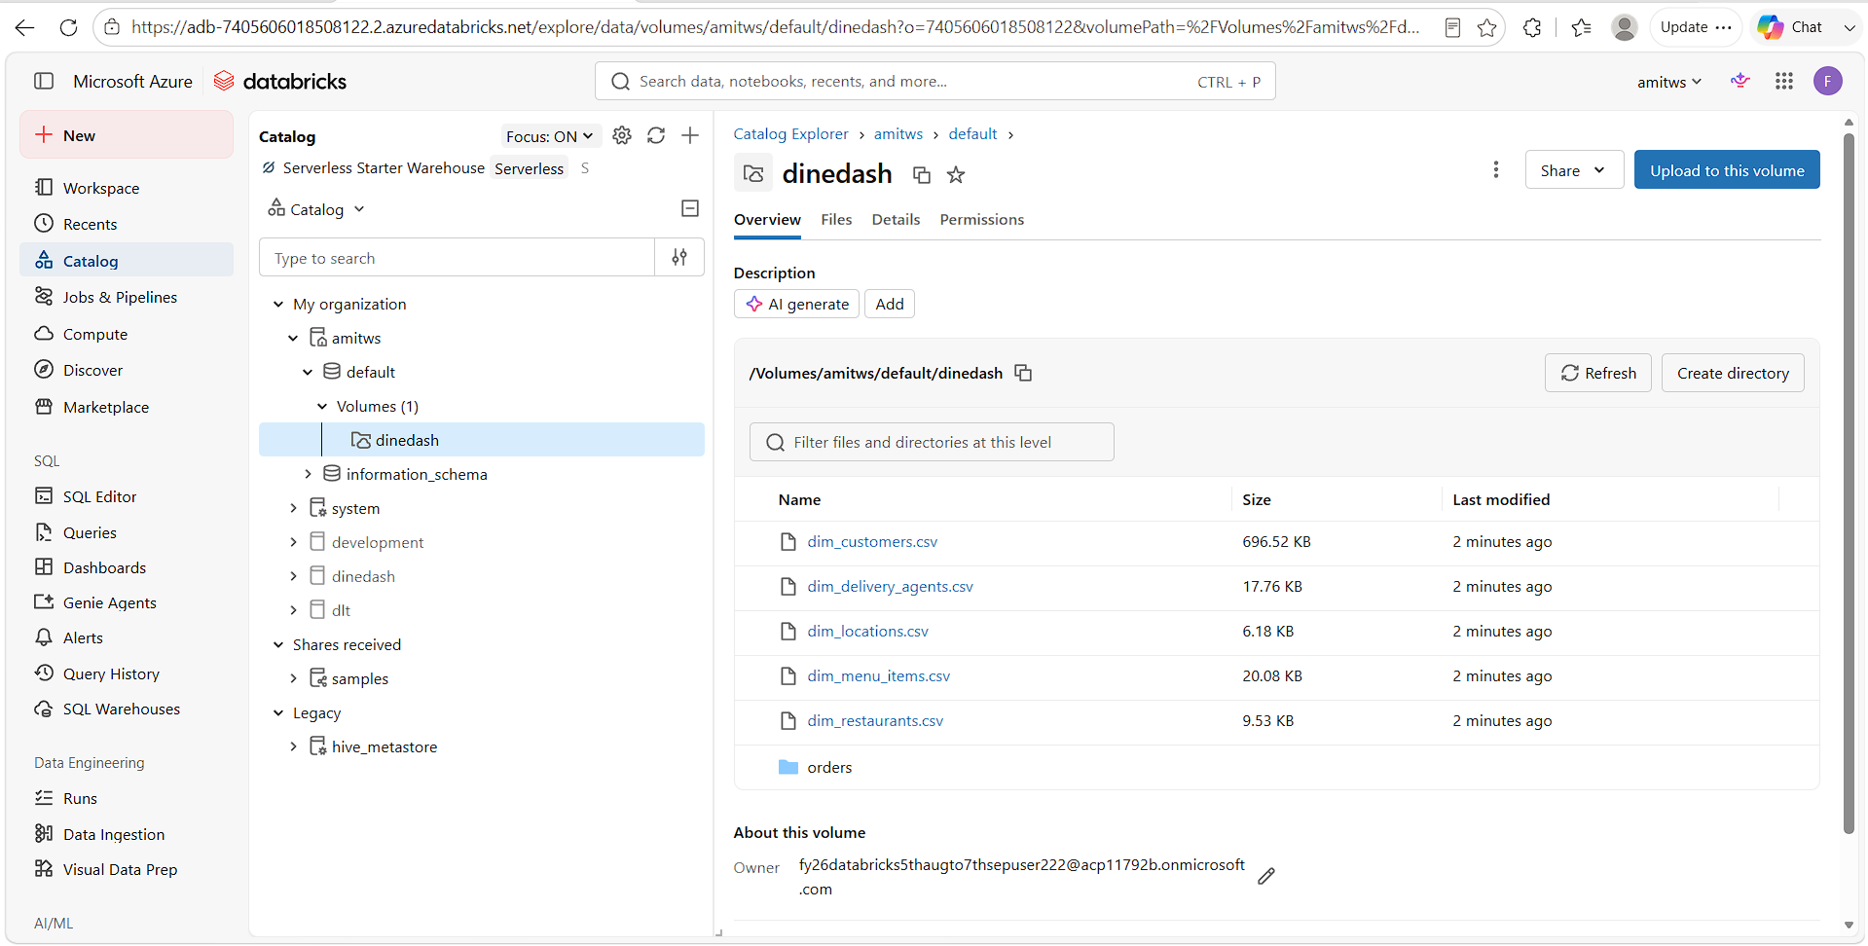

INITIAL DATA EXPLORATION:
TEMPORARY VIEW: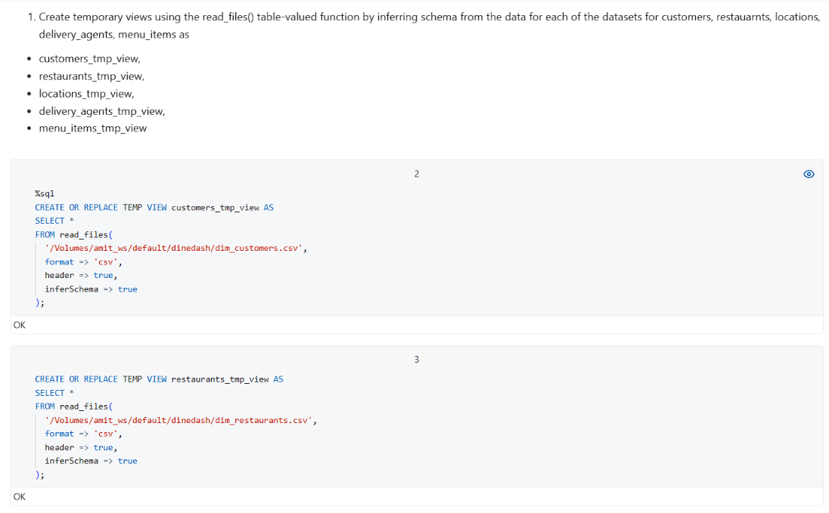 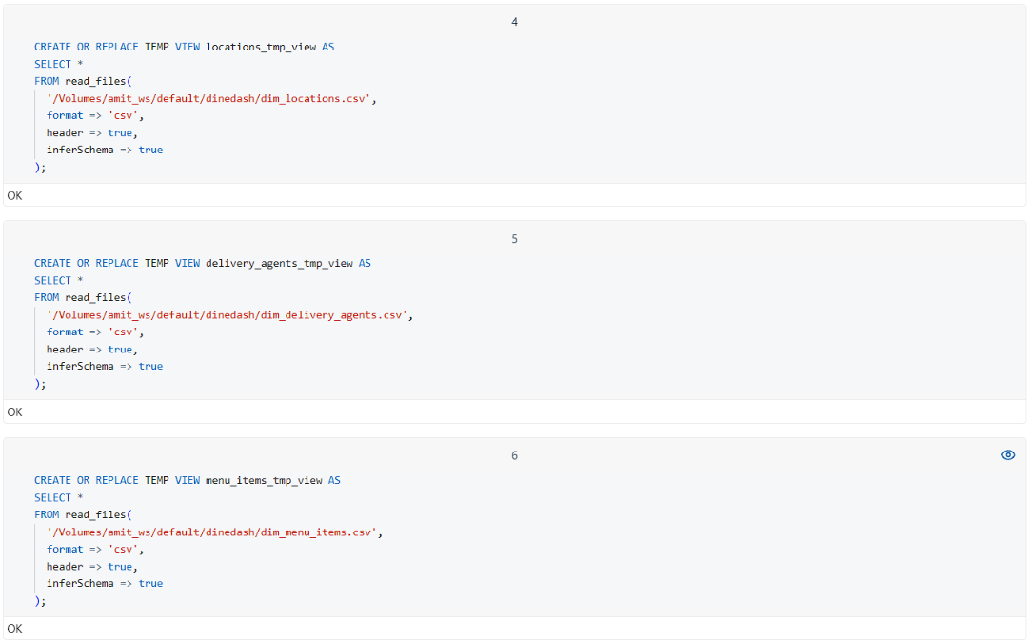

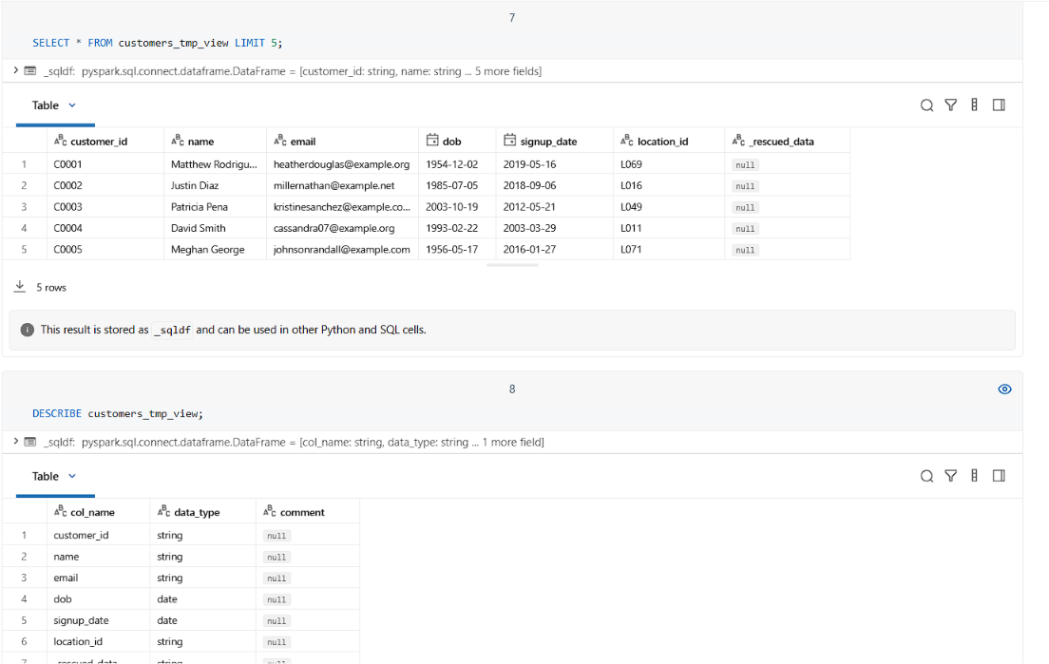

CREATING RAW DELTA TABLES:
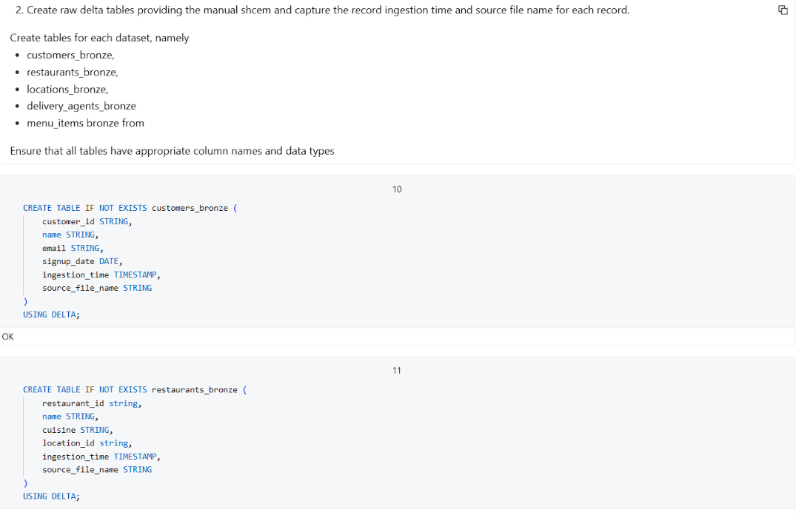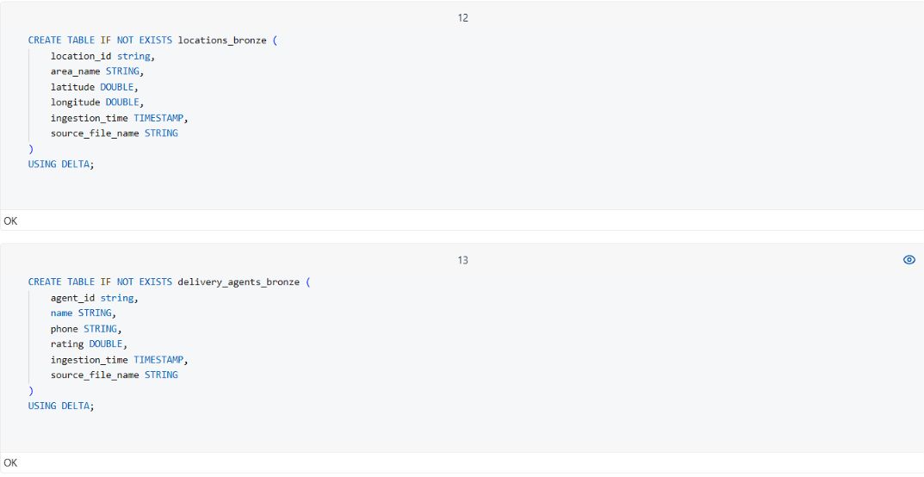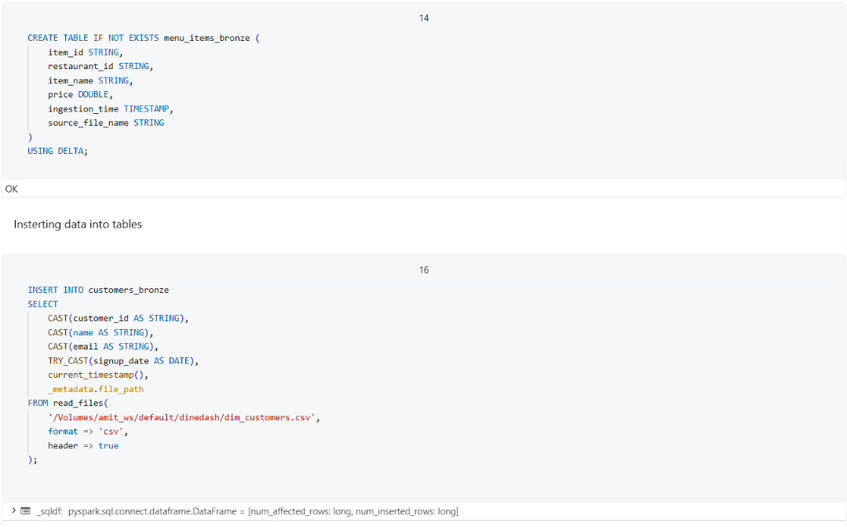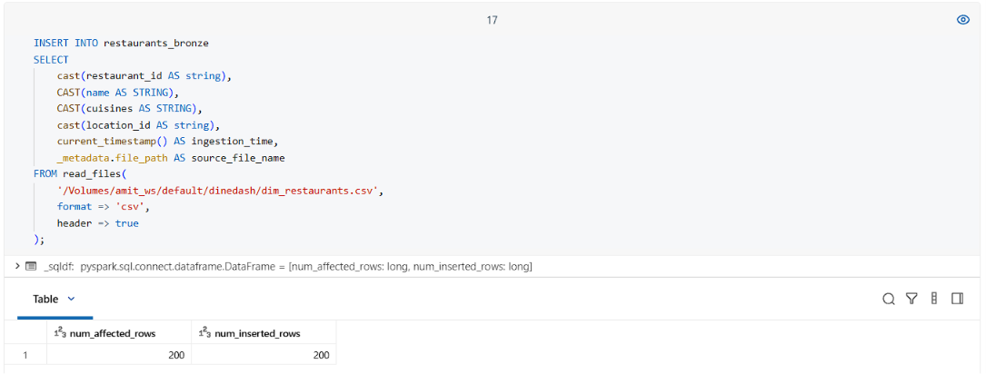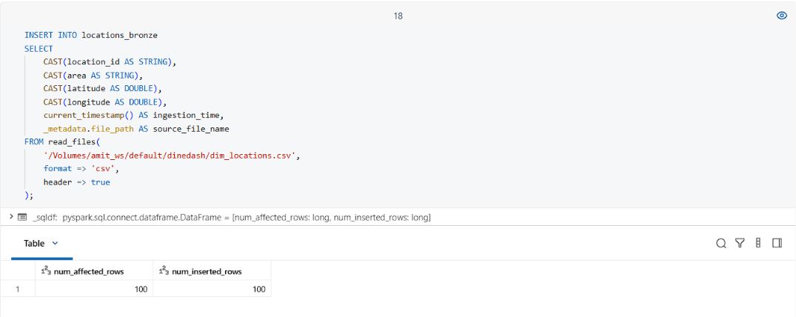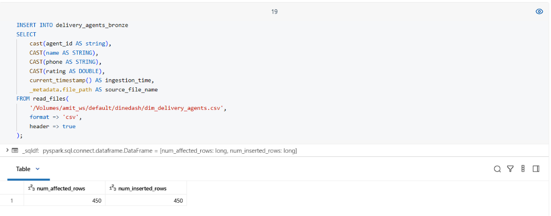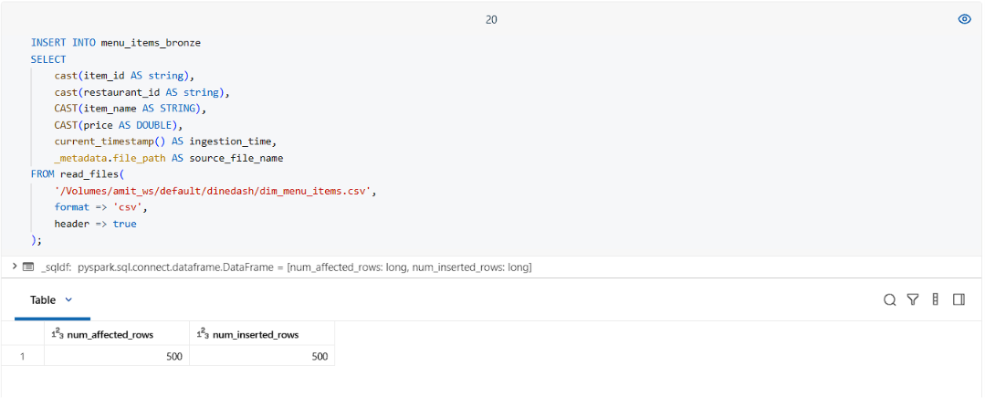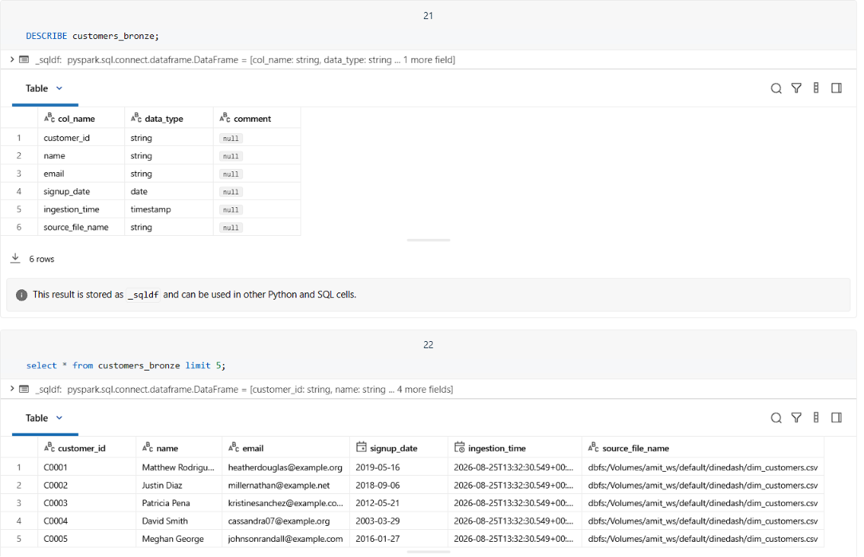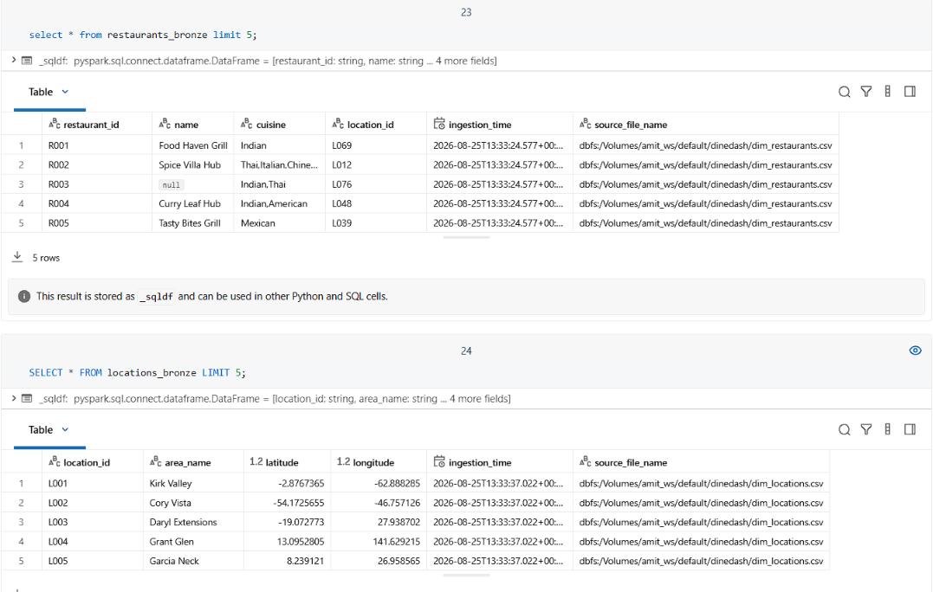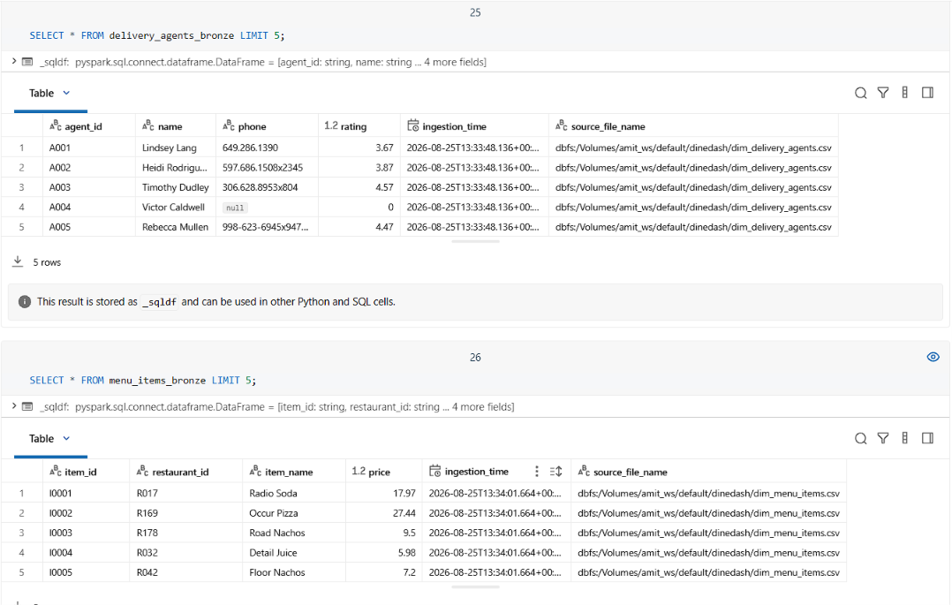

CLEANED DATA DELTA TABLES (FILTERED):
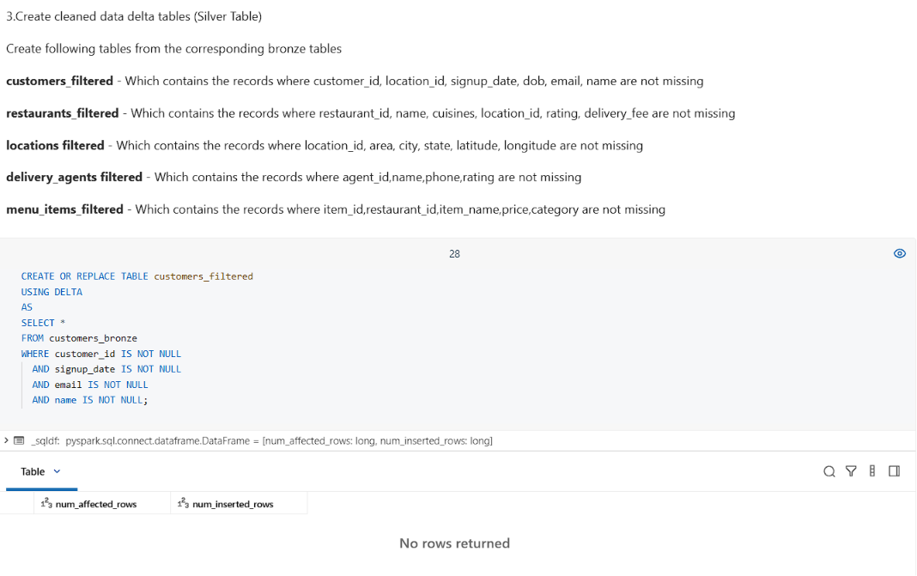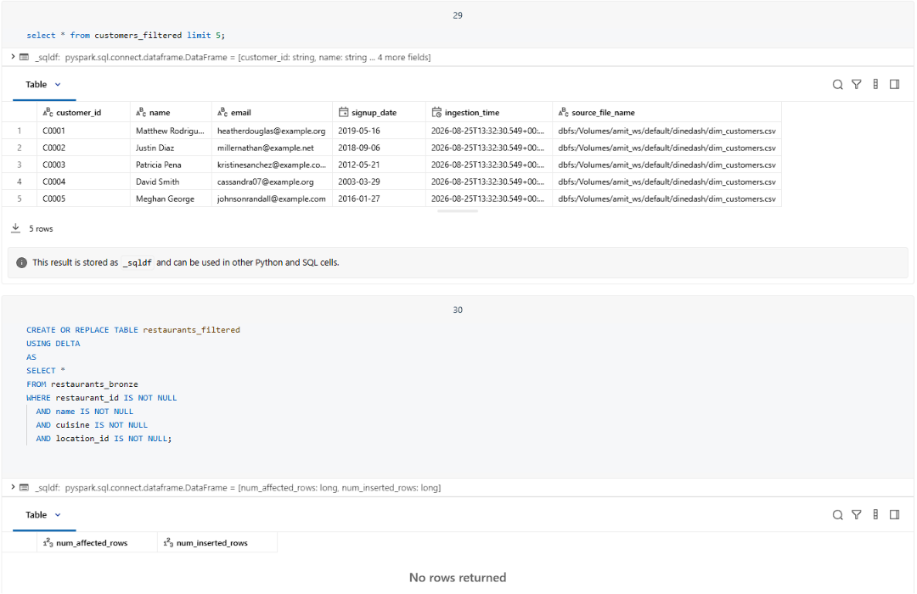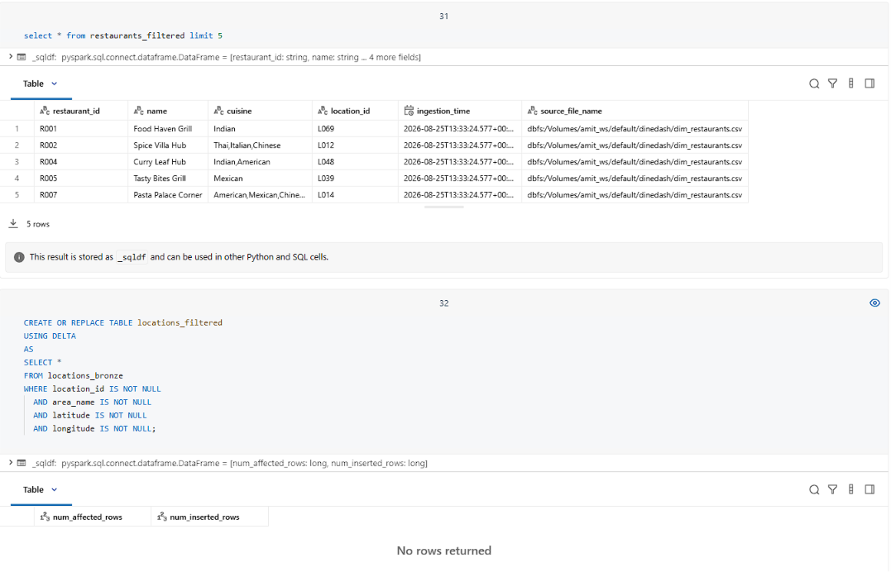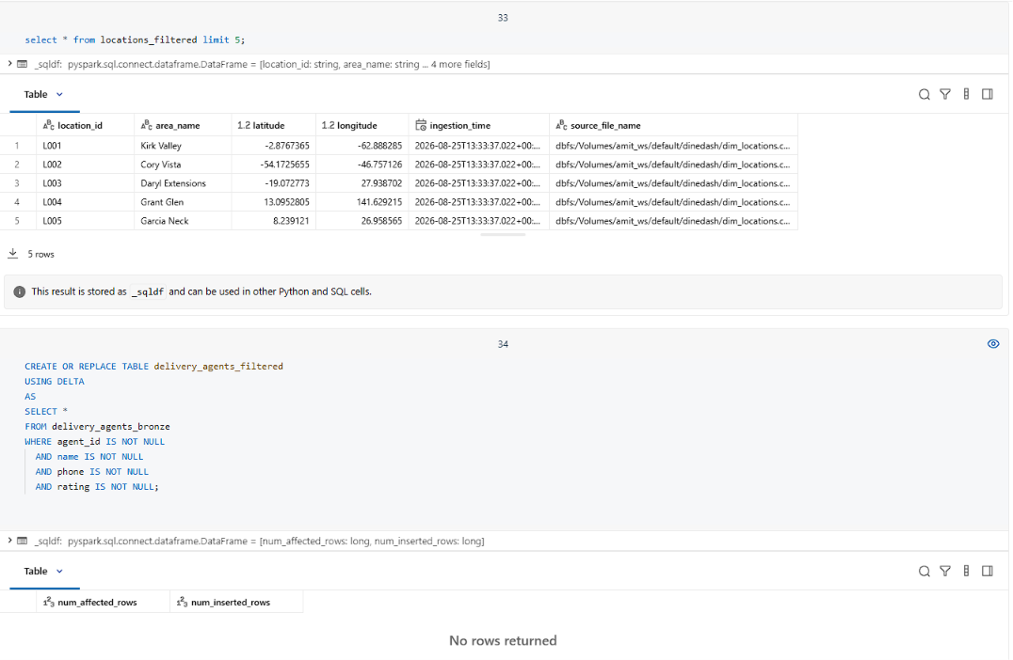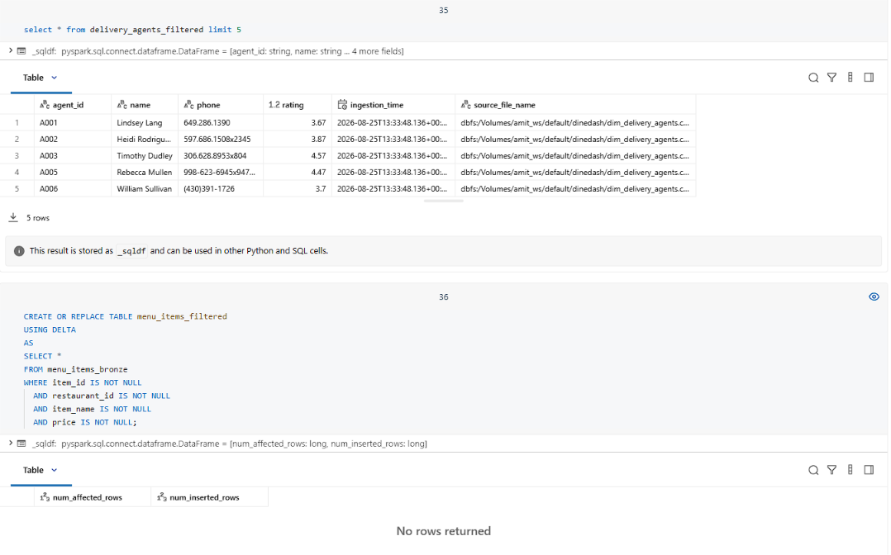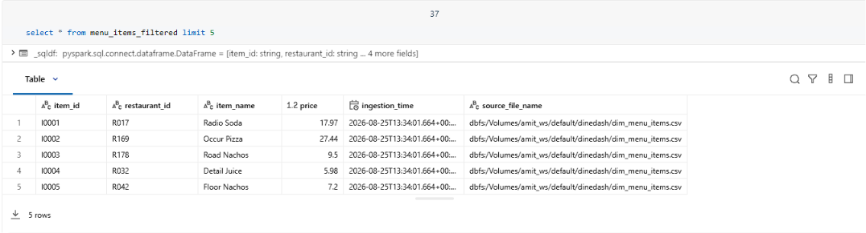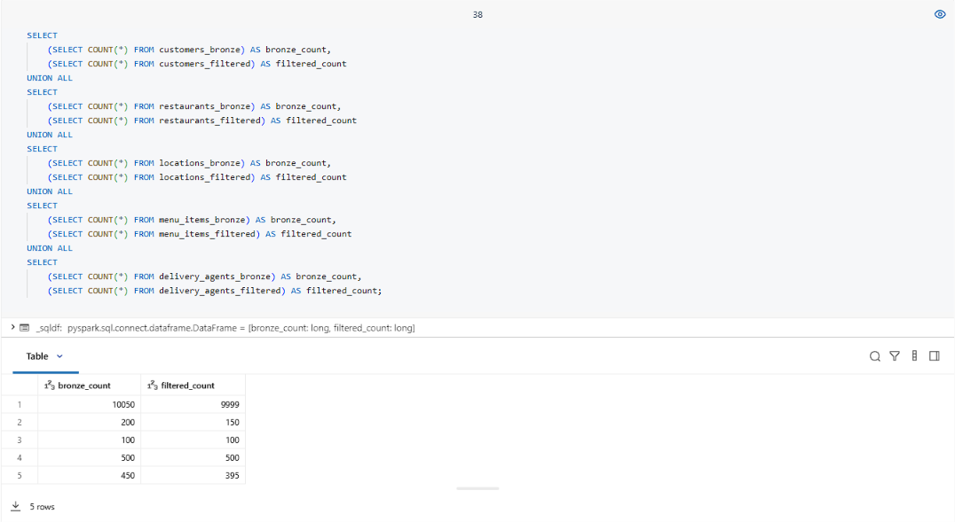

INCREMENTAL DATA LOADING:
Created the orders_bronze table using the COPY INTO command to load the January and February order data incrementally from the source files.
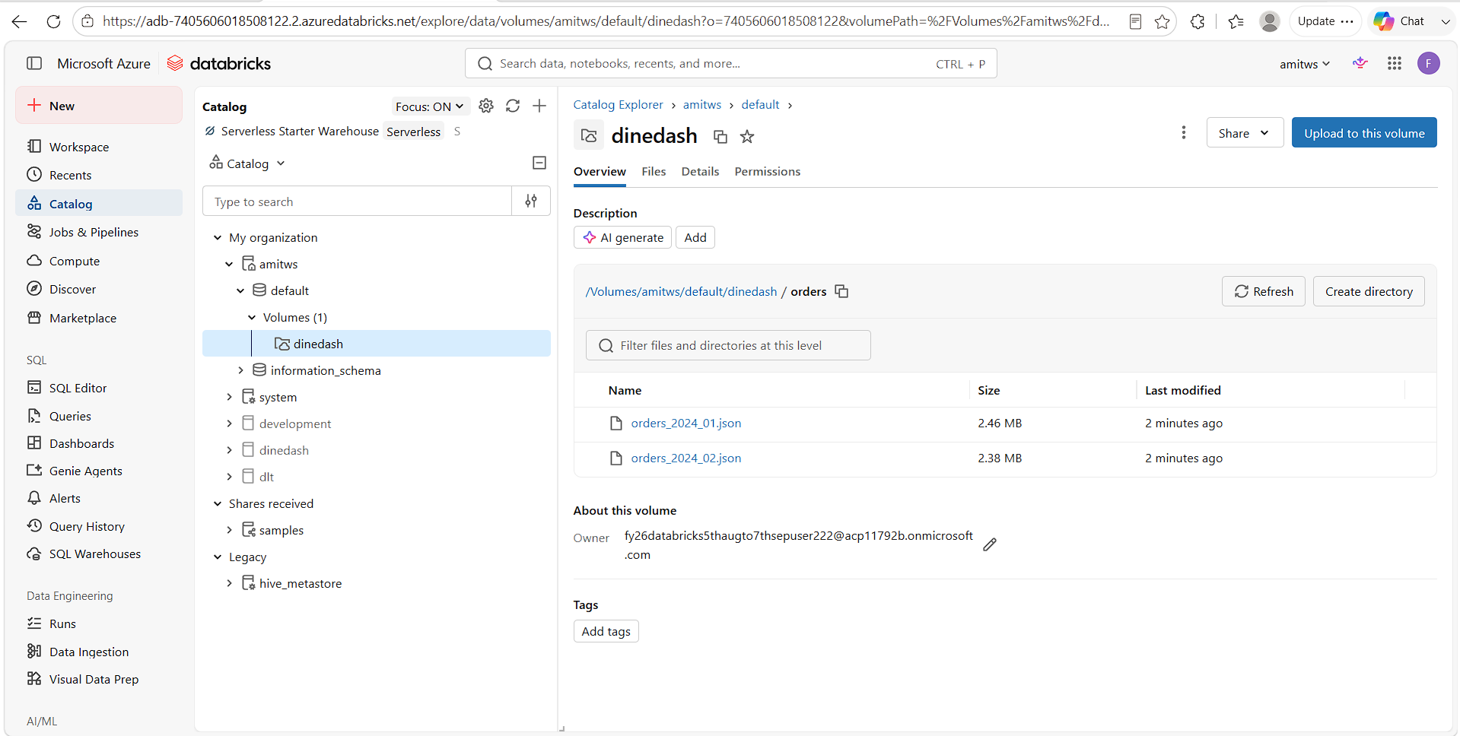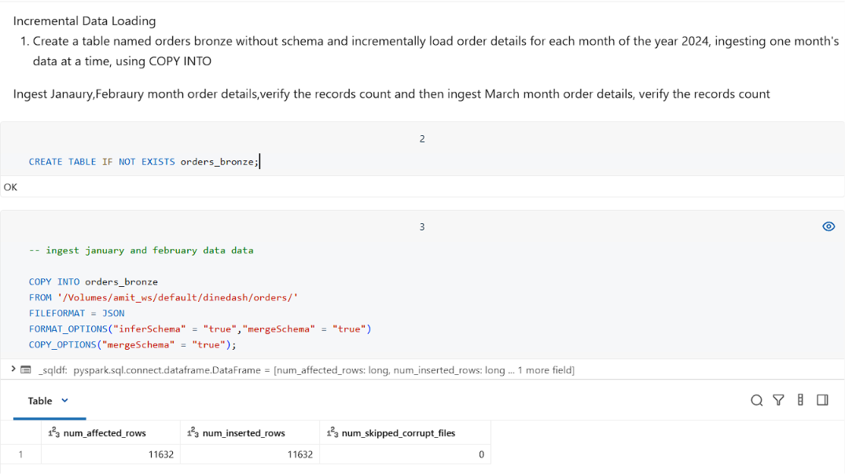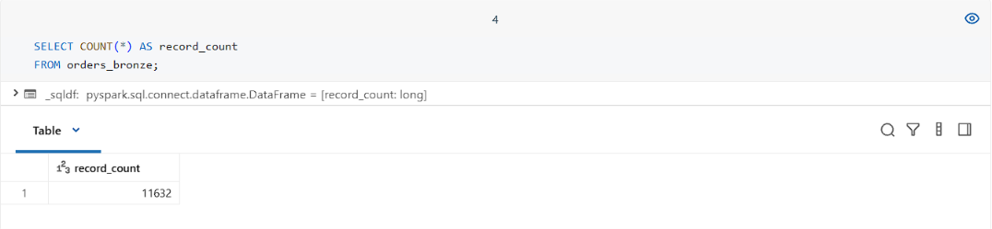
March data ingested: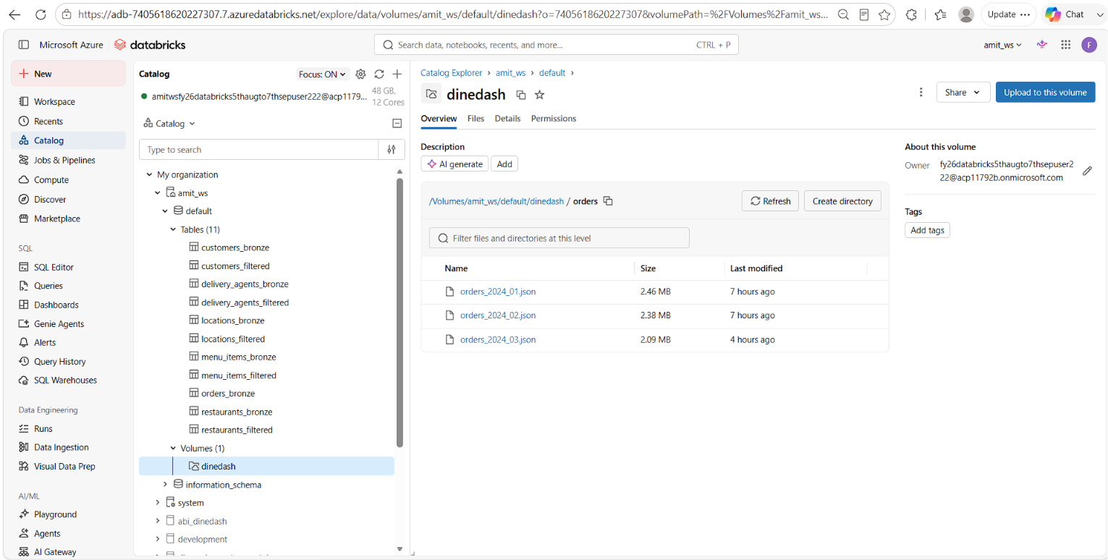 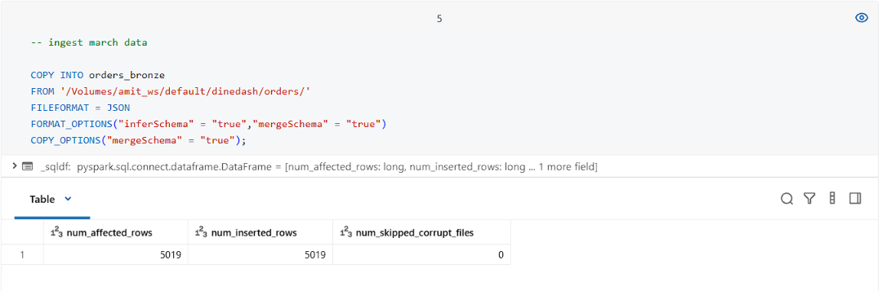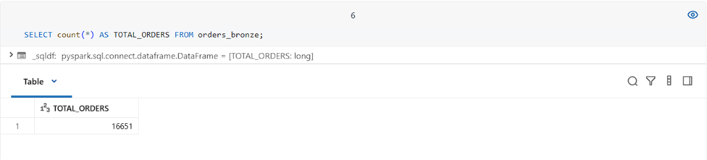

PROBLEM STATEMENT: ORDER DATA ANALYSIS
- Total number of orders placed.
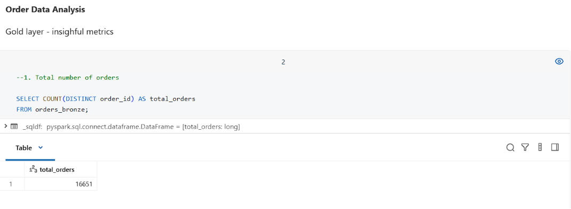
- Distribution of orders by payment method.
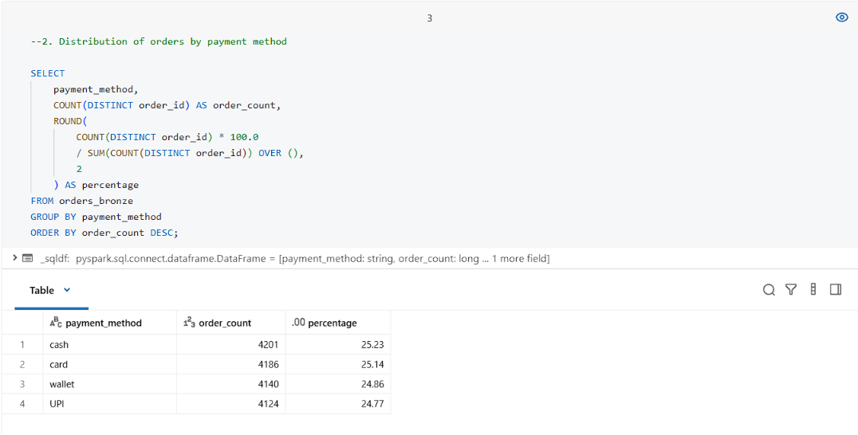

- Distribution of order status (e.g., delivered, preparing, cancelled).
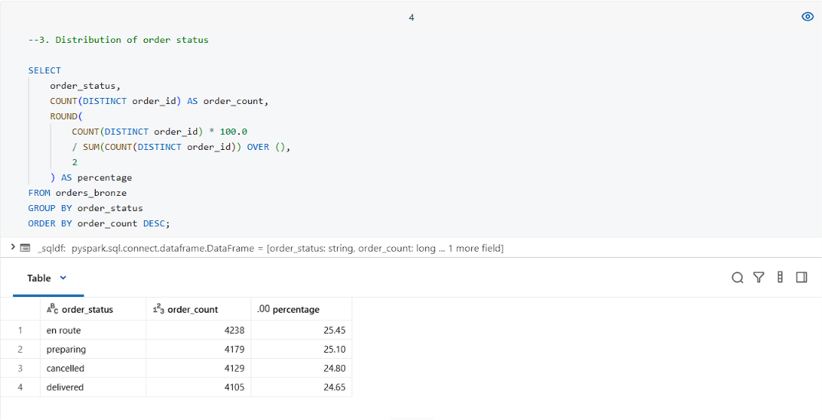
- Orders per restaurant (volume of business).
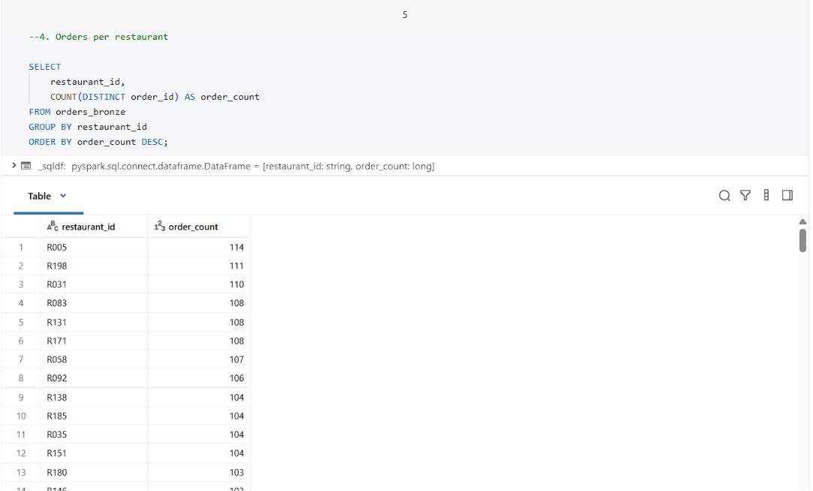

- Orders per customer (loyalty insight).
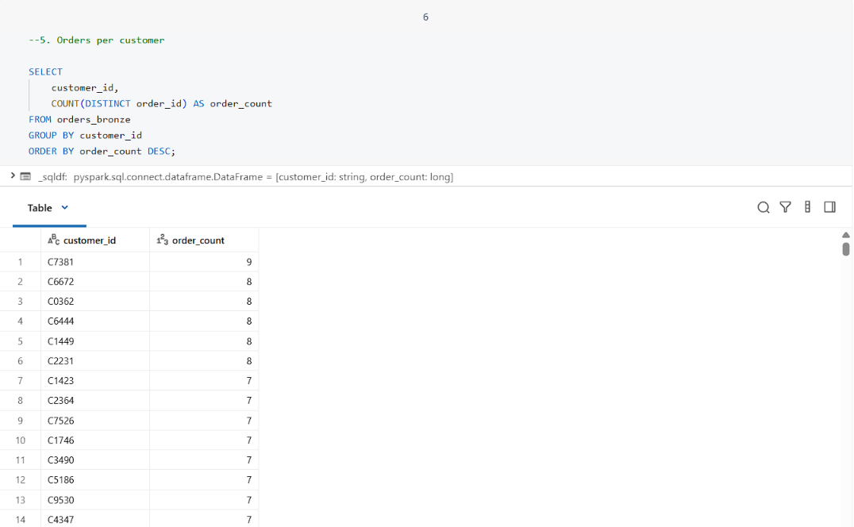
- Orders handled per delivery agent.
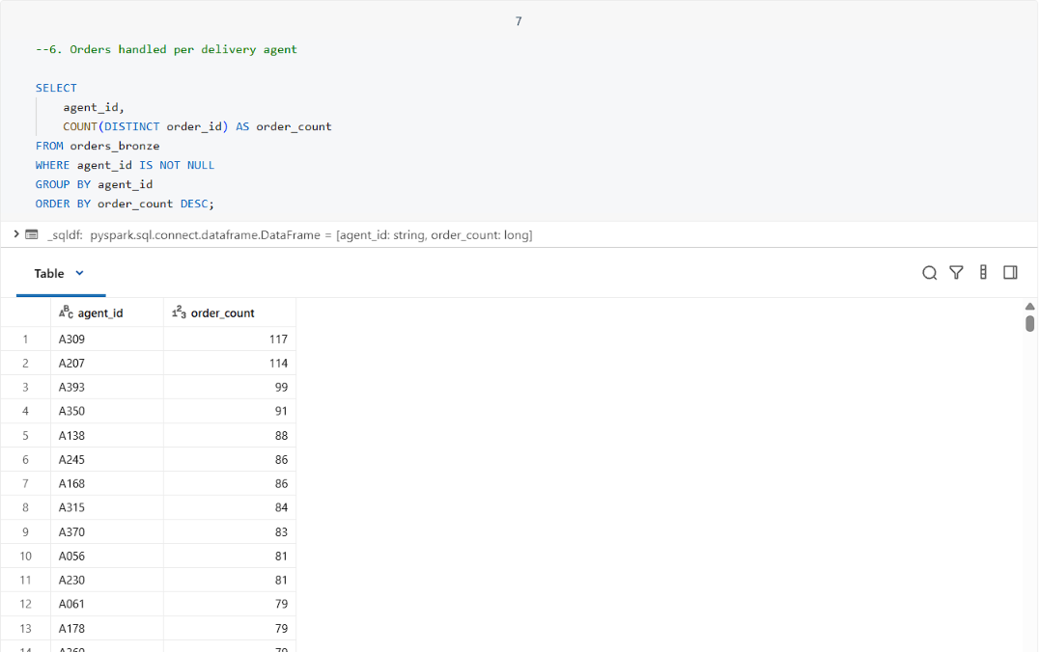

- Top 10 orders by total amount.
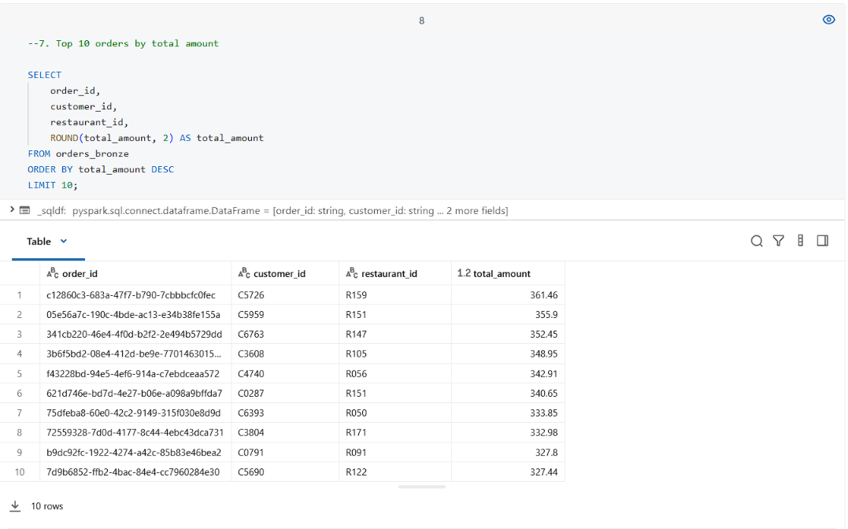
- Average tip amount per payment method.
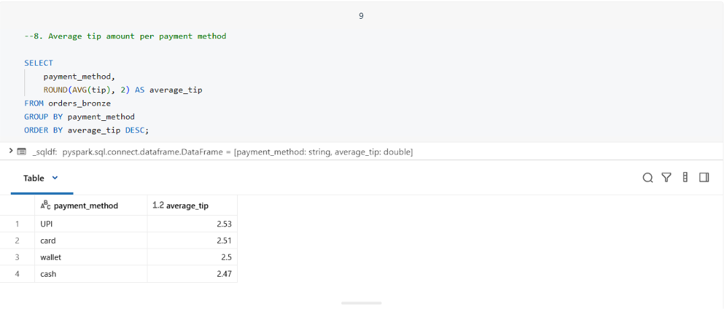

- Percentage of orders with tip > 10% of total_amount.
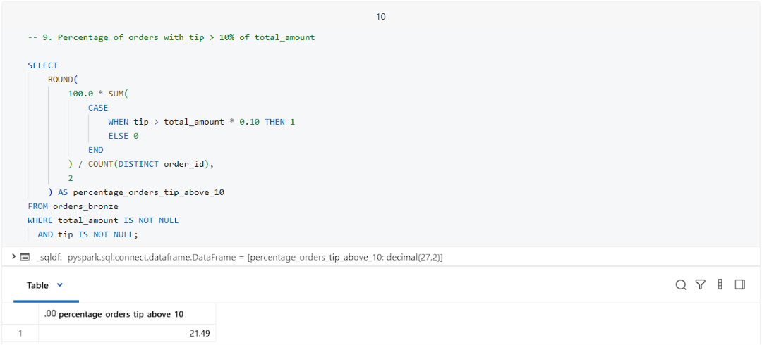
- Percentage of successful vs cancelled vs failed orders.
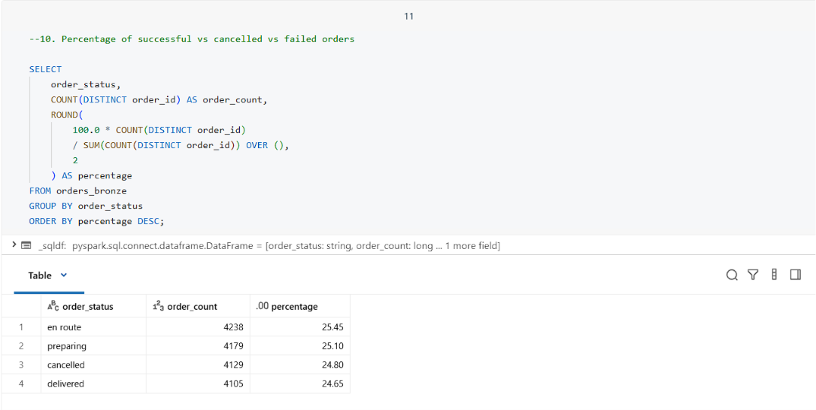

- Top customers (by number of orders) and top restaurants (by number of orders).
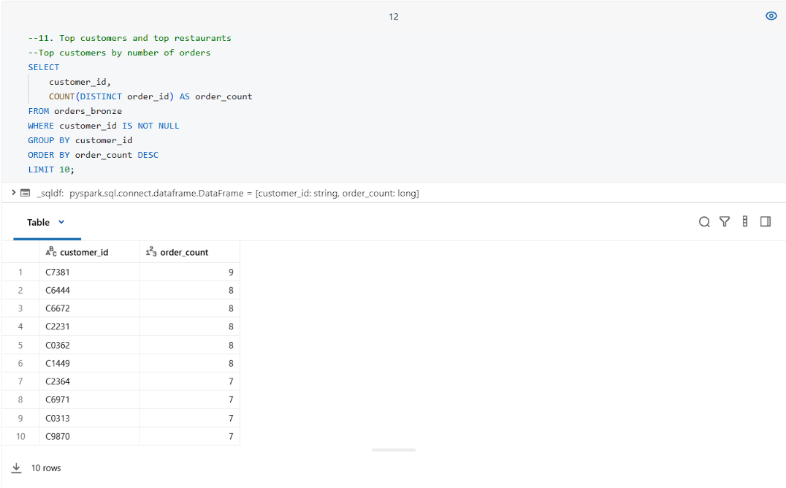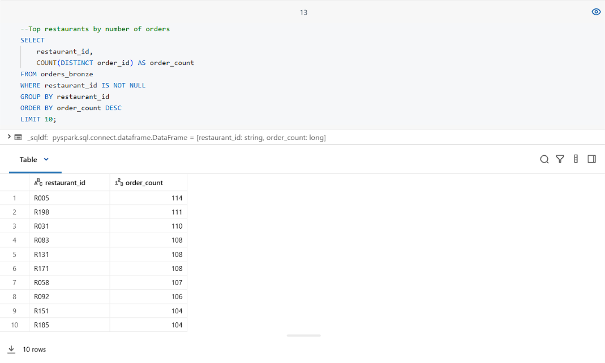

- Item-Level Insights (explore items_ordered):
- Find the most frequently ordered items.
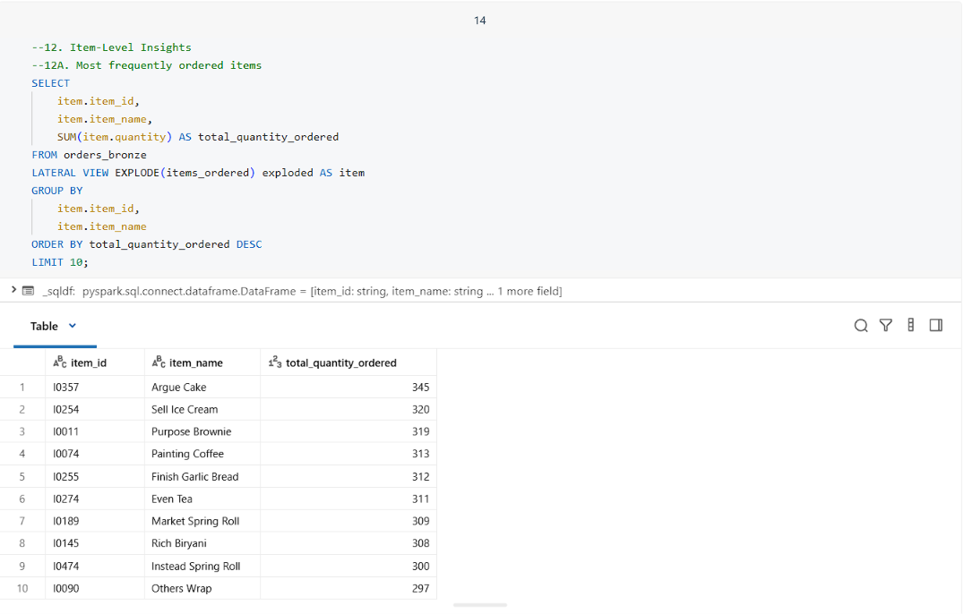
- Find the average number of items per order.
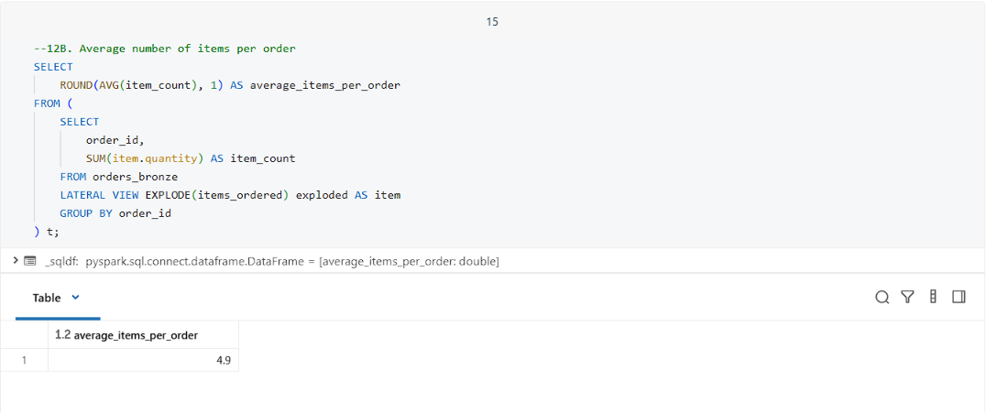

- Find item revenue contribution per restaurant.
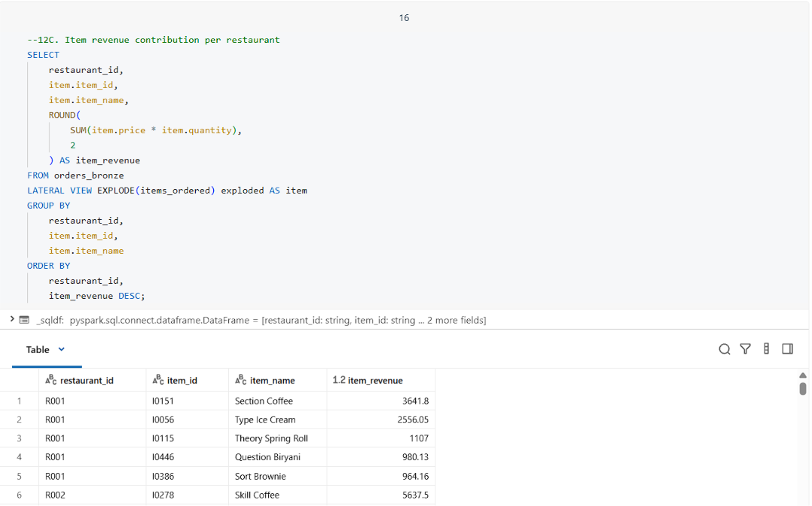

ORDERS DATA AND DIMENSION DATASETS ANALYSIS
- Find the preferred restaurant names for each customer.
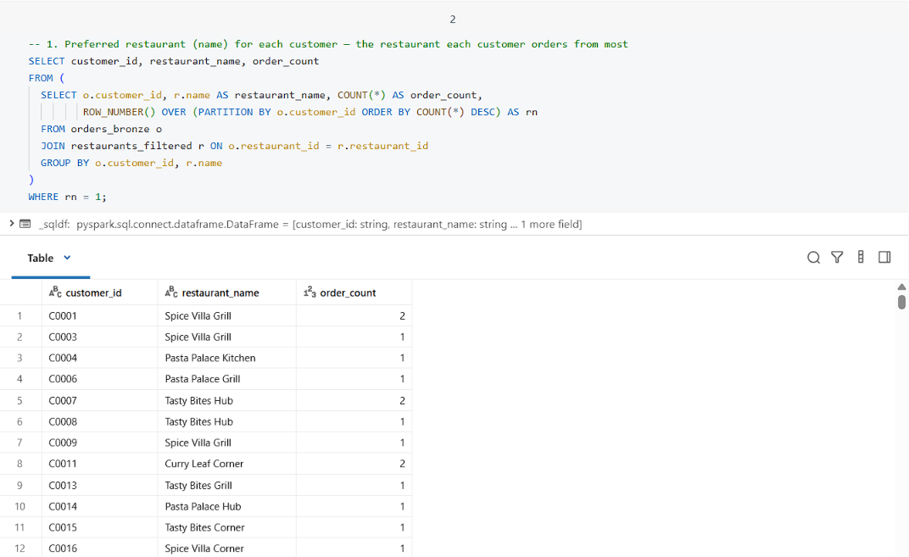

- Find the top 10 areas receiving orders in each month.
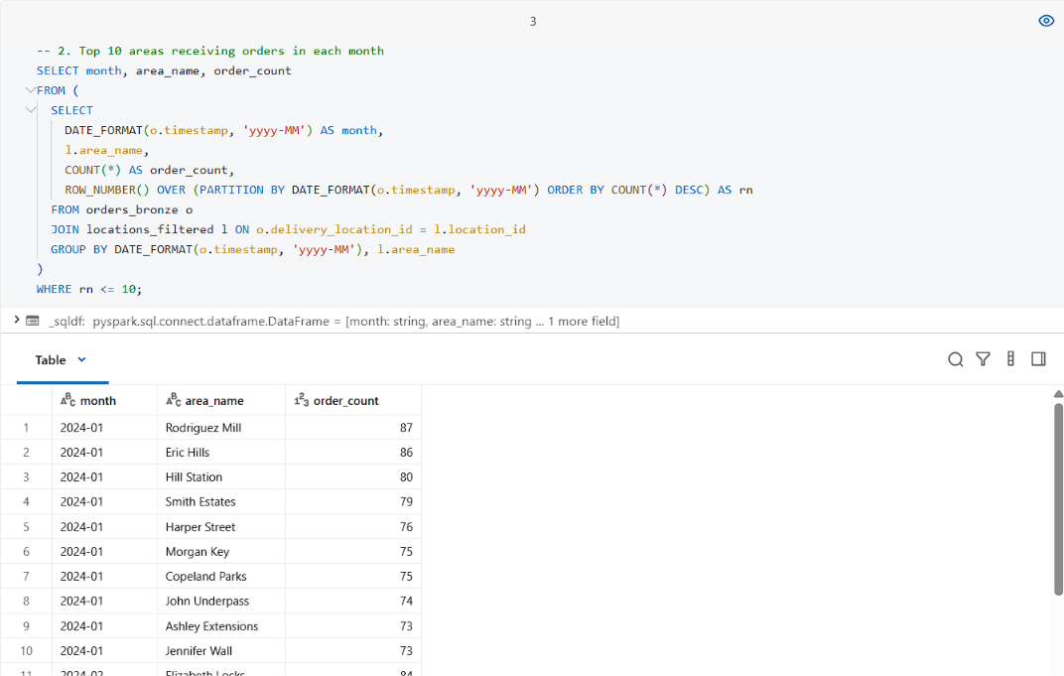
- Find all successfully delivered orders that were paid using a card, to analyze payment preferences and delivery success rates.
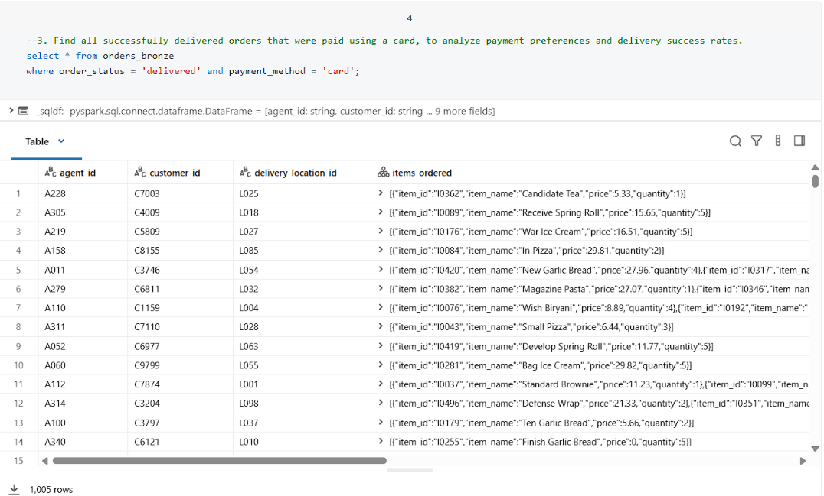
- Which cuisines generate the highest average order value? Hint: Join orders, restaurants, group by cuisine, and calculate average total_amount.
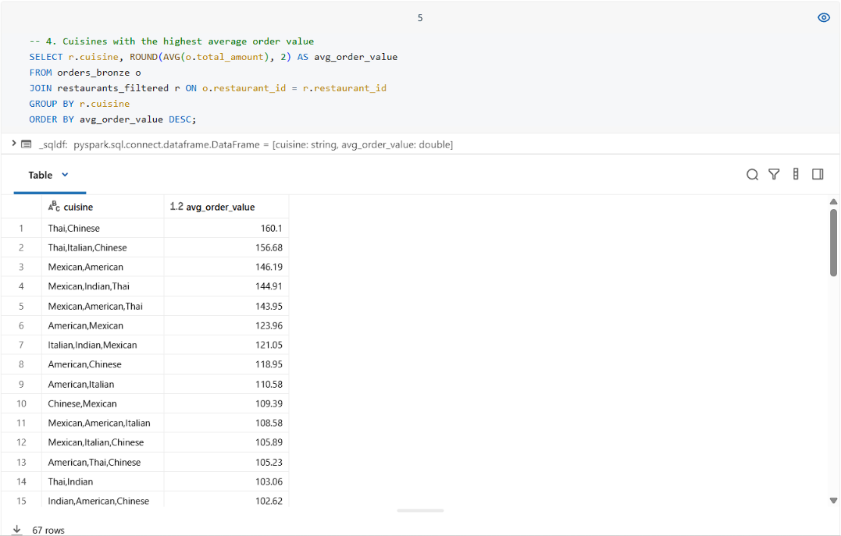

- Which delivery agents have delivered the most high-value orders (above $50)? Hint: Filter orders for total_amount > 50, join with agent, group by agent_id, and count orders.
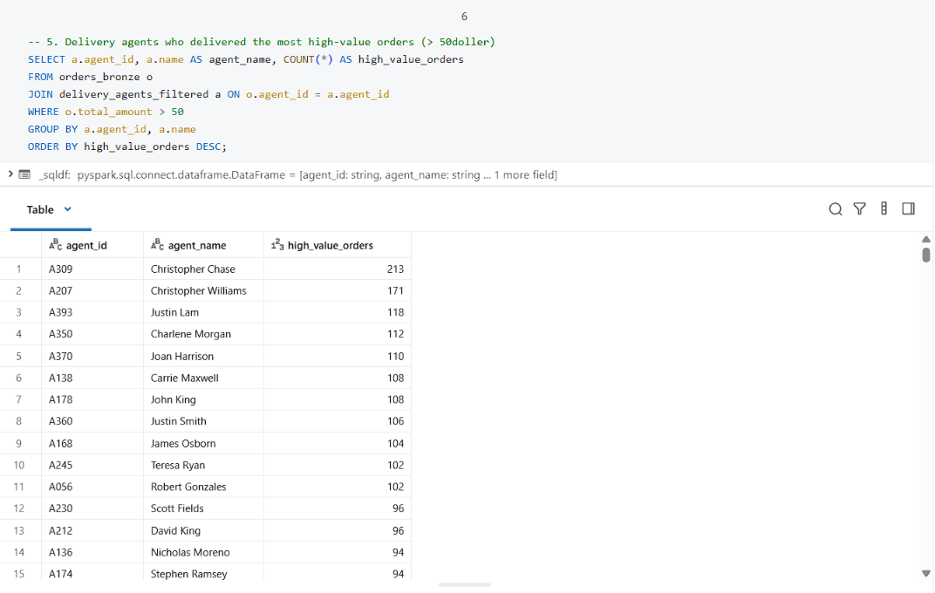
- Which cities (area_name) are generating the most revenue for Italian restaurants? Hint: Join orders, restaurants, locations, filter cuisine = 'Italian', group by area_name, and sum total_amount.
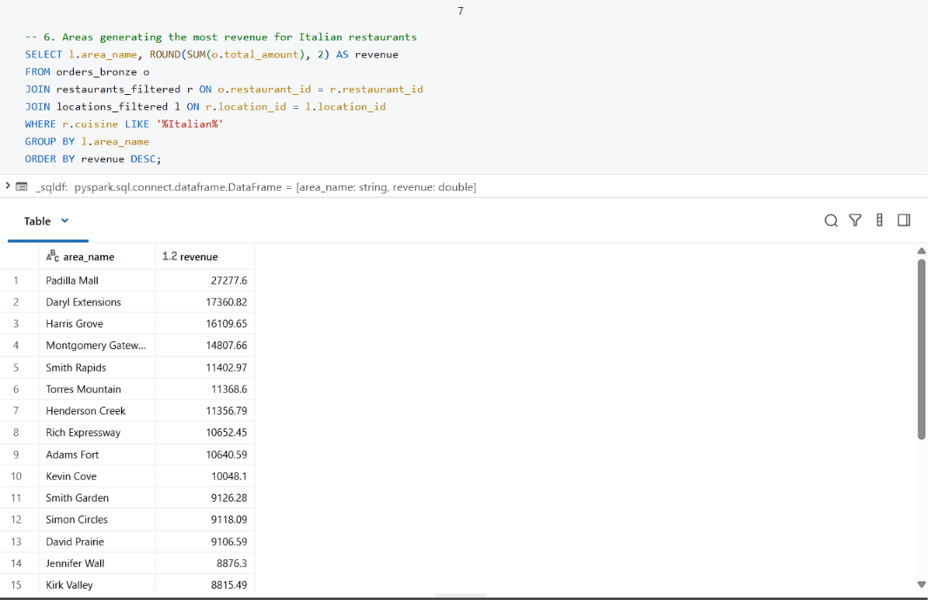
- What is the tip-to-total ratio by cuisine type? Hint: Join orders, restaurants, group by cuisine, and calculate average tip / total_amount.
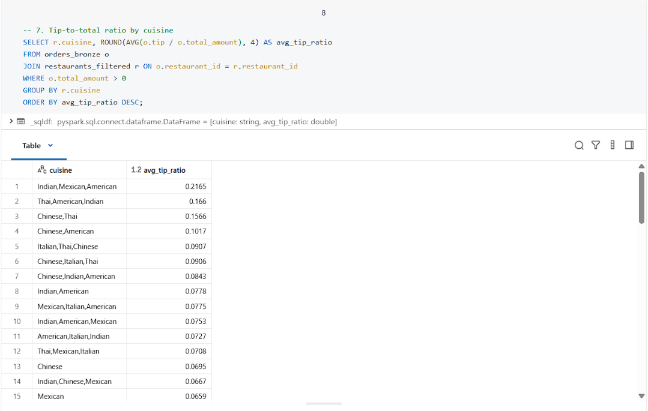
- Which menu items are most frequently ordered, and from which restaurants? Hint: Explode items_ordered in orders, join with menu_items, group by item_name, restaurant_id, and count.
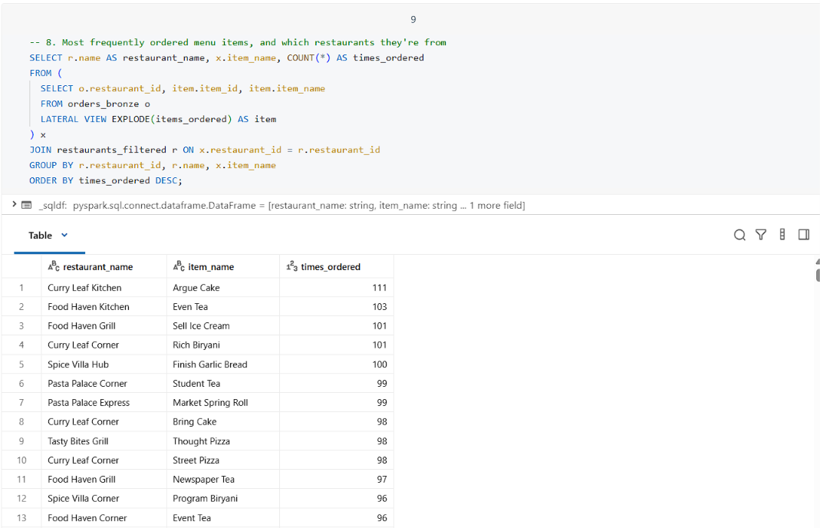
- Which agents have delivered the most diverse cuisines? Hint: Join orders, restaurants, group by agent_id, and count distinct cuisine.
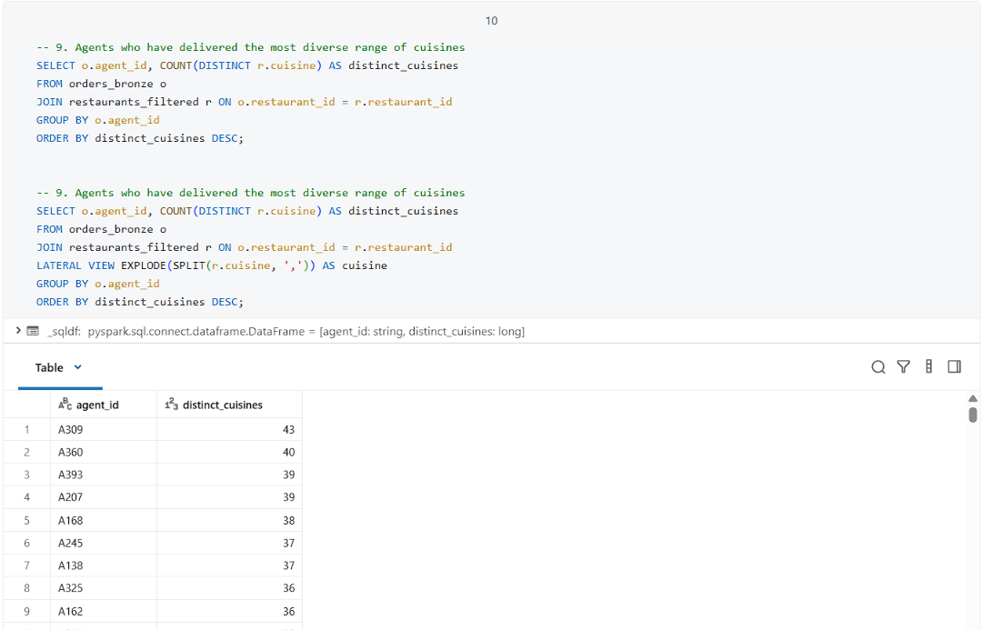
- What is the average customer lifetime value by signup year? Hint: Join orders, customers, extract year from signup_date, group by year, sum total_amount per customer, then average total_amount per customer.
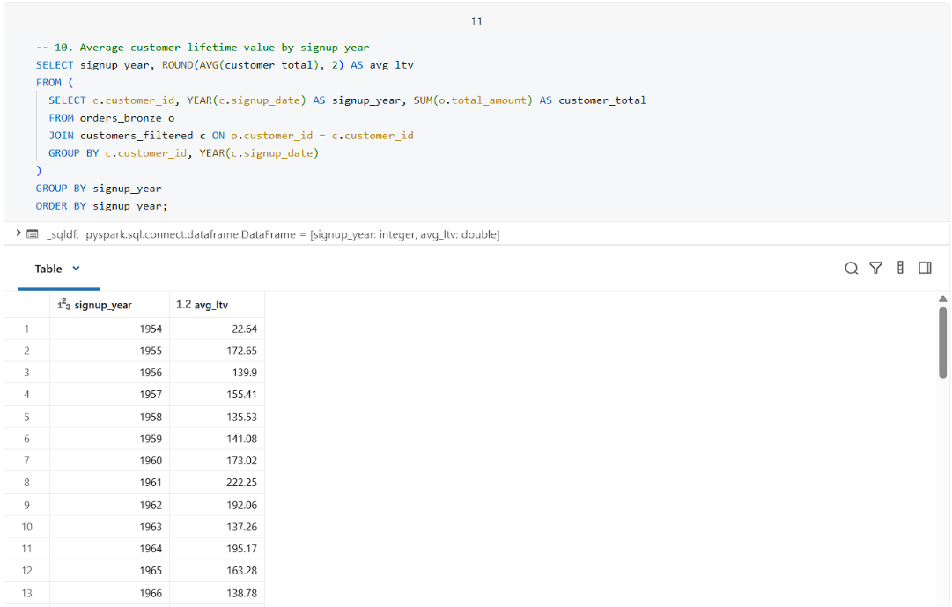
- Which restaurants have the highest order frequency per location? Hint: Join orders, restaurants, locations, group by restaurant_id, location_id, and count orders.
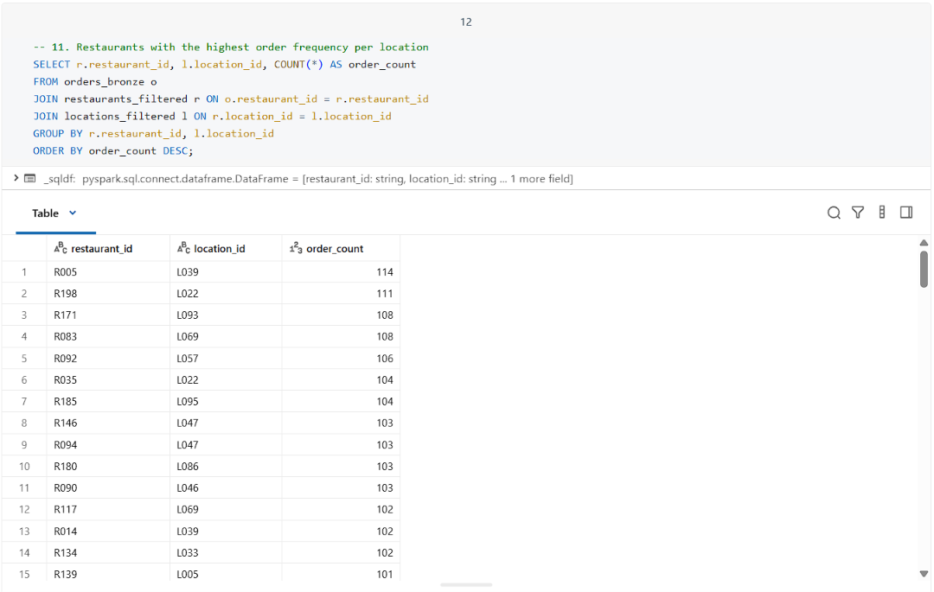
- Which locations are prone to order cancellations? Hint: Filter orders with order_status = 'cancelled', join locations using delivery_location_id, group by area_name, and count.
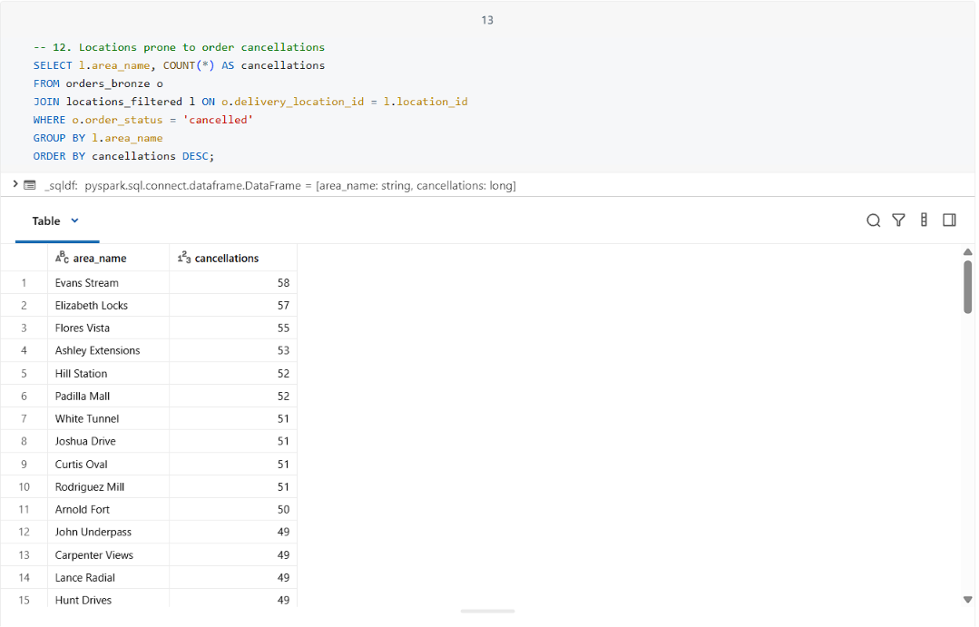

- Find the top 10 customers who have ordered from the widest variety of restaurants. Hint: Join orders, group by customer_id, count distinct restaurant_id, sort, and pick top 10.
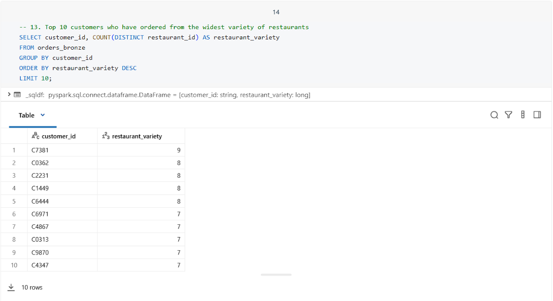
- Identify restaurants with frequent repeat customers. Hint: Join orders, group by restaurant_id, customer_id, count, and filter where count > 1.
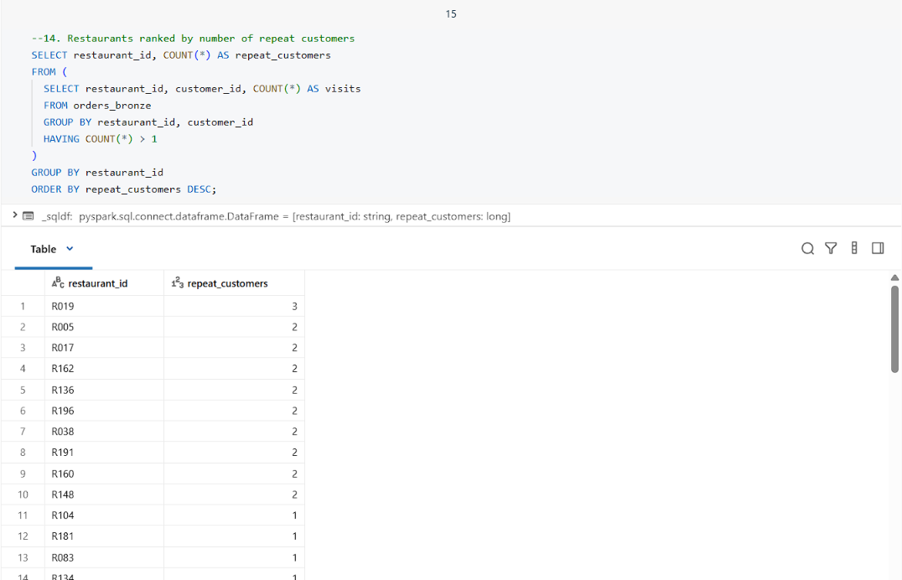

- Which payment methods are most preferred for high-value orders across cuisines? Hint: Filter orders with total_amount > 40, join restaurants, group by cuisine, payment_method, and count.
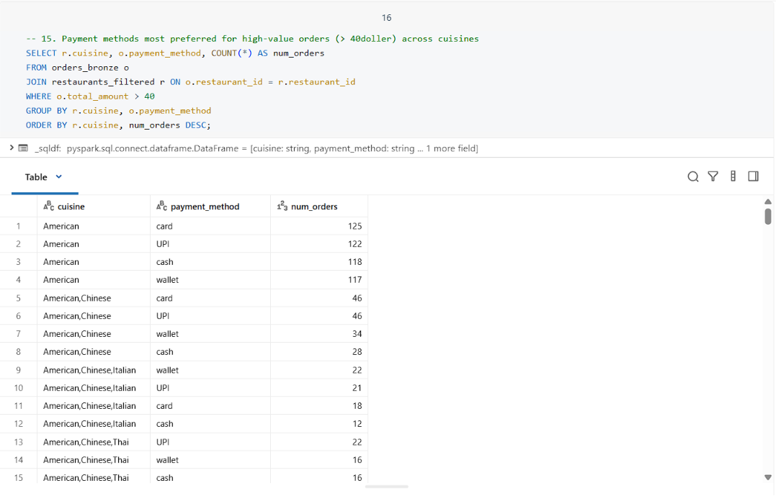

DELTA LIVE TABLES:
APRIL-MAY-JUNE DATASET INGESTED
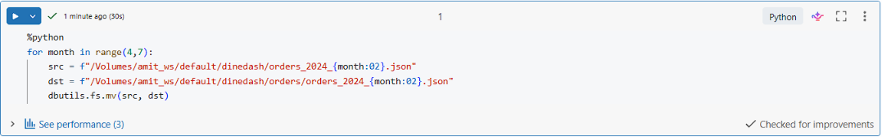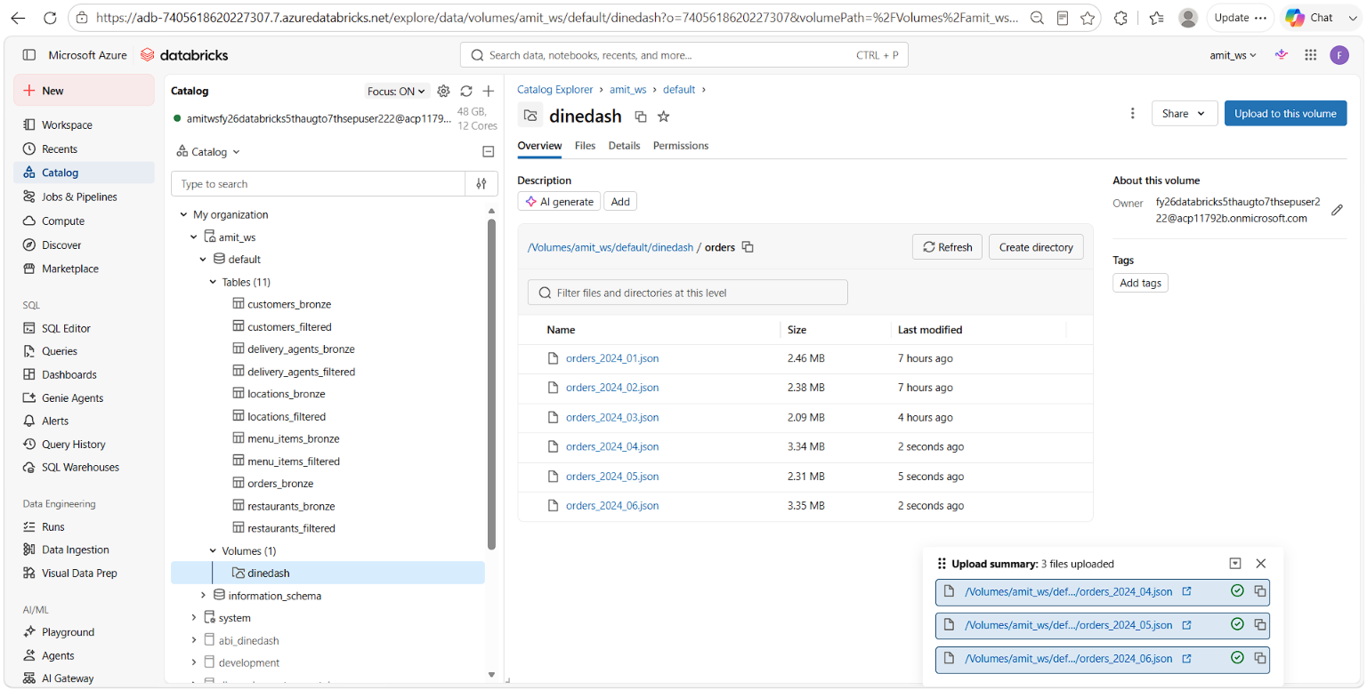

DLT PIPELINE SCRIPT CODE: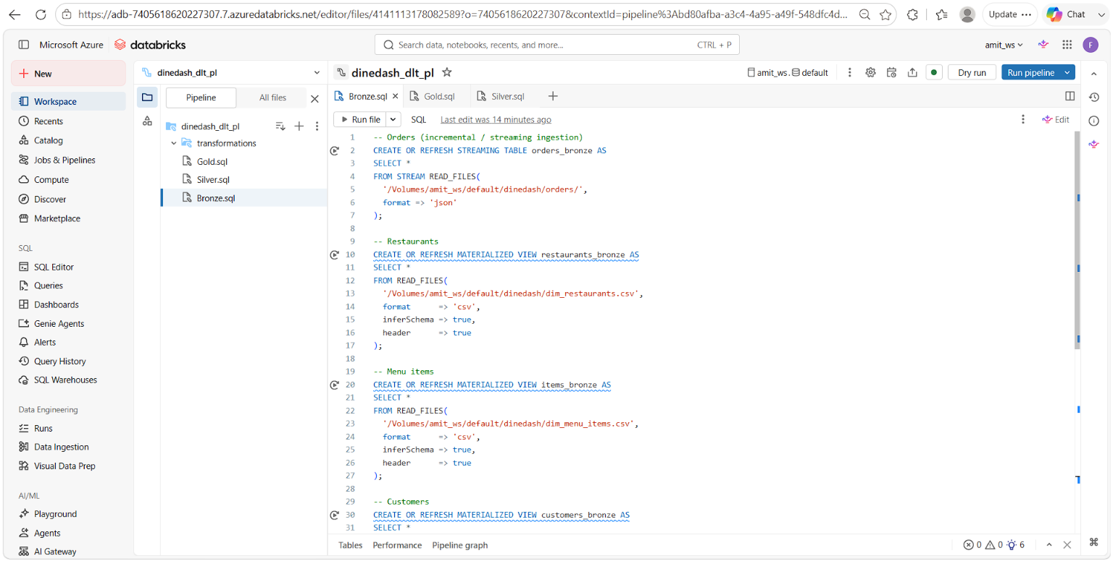 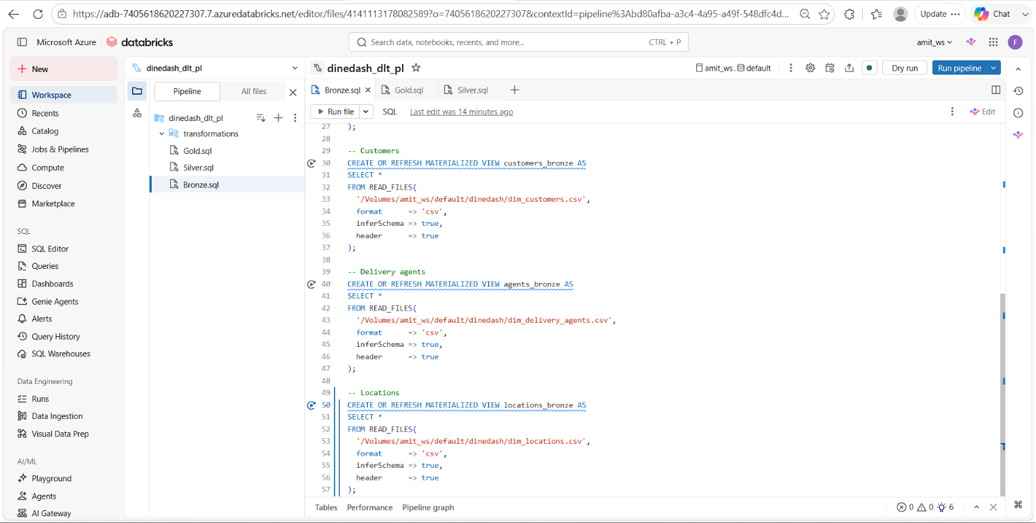 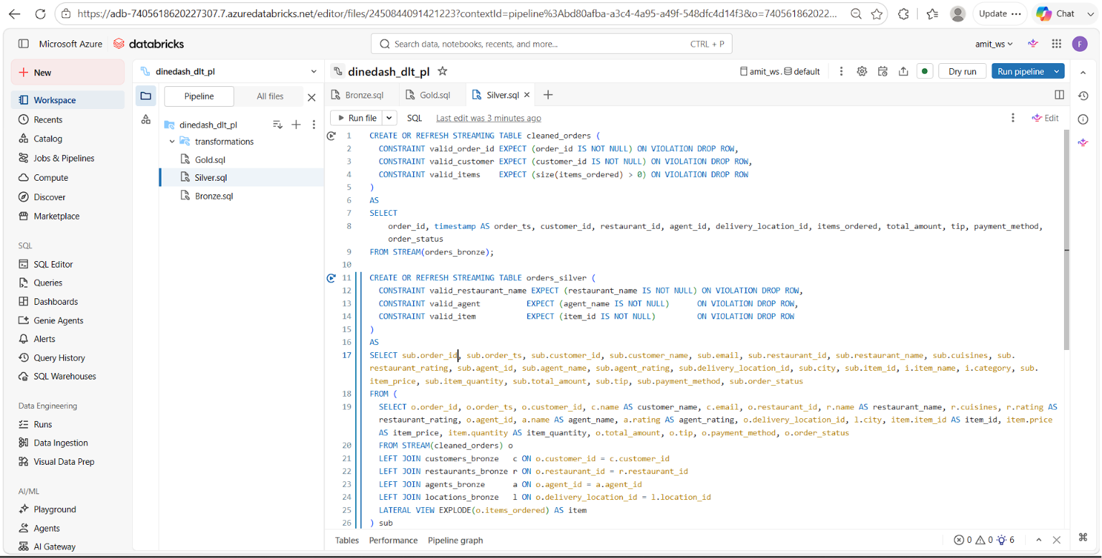 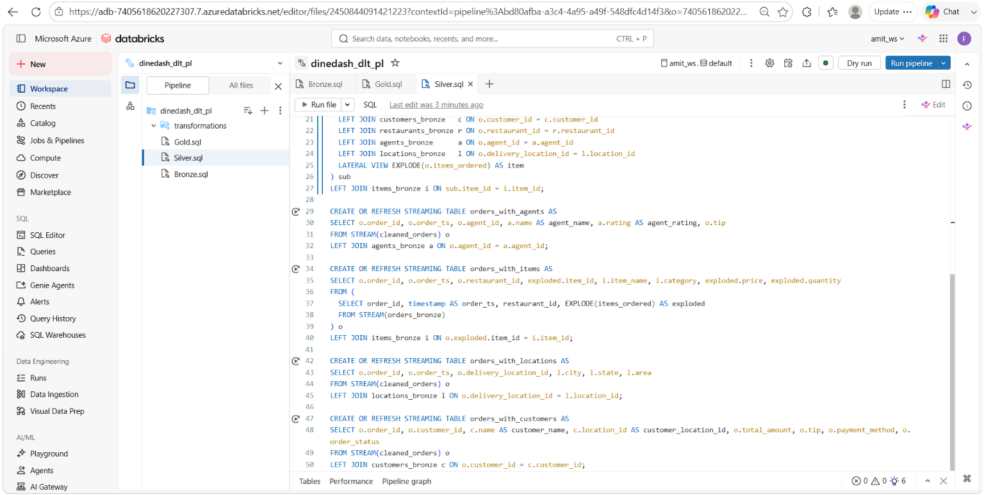 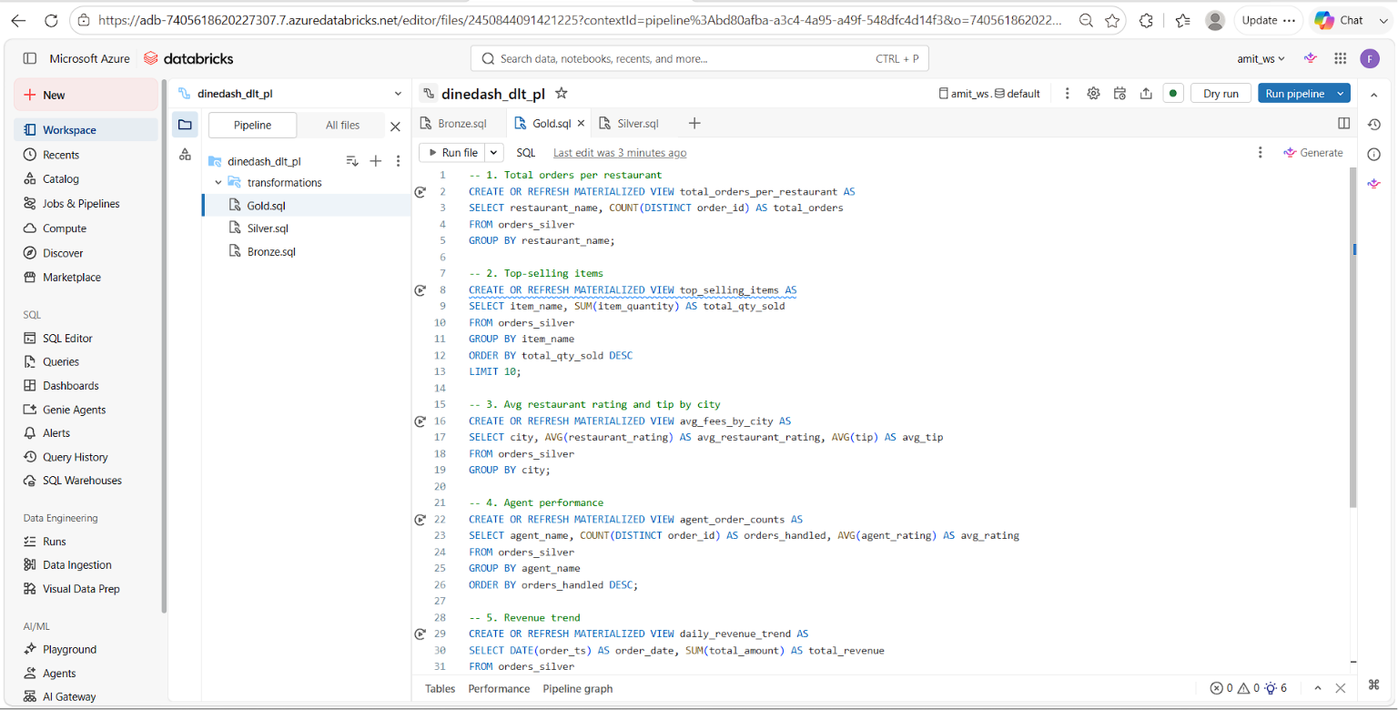 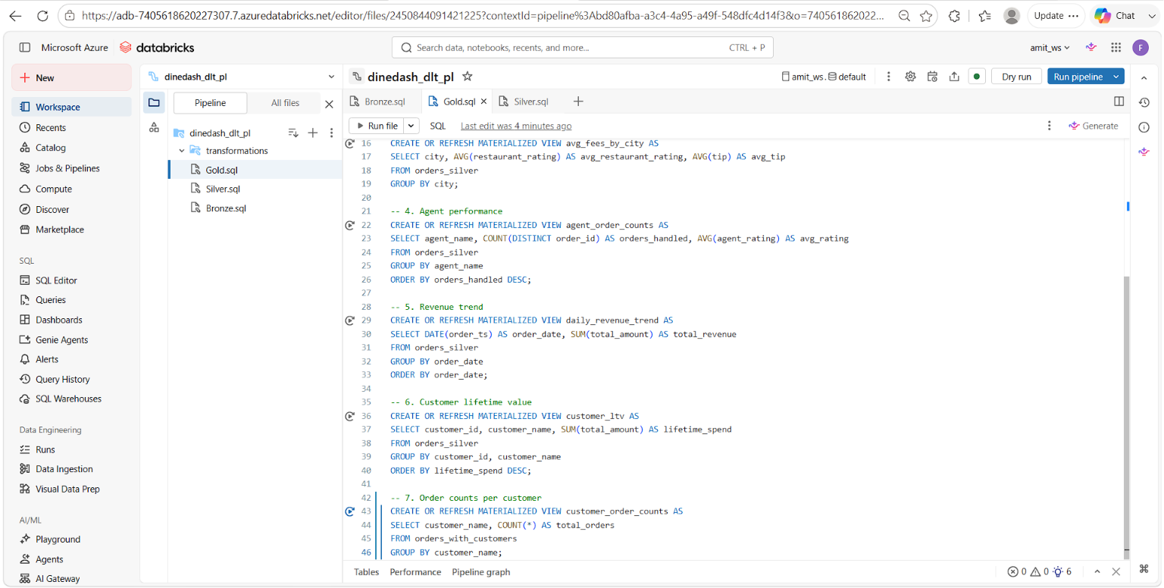

PIPELINE EXECUTION (JANUARY-JUNE):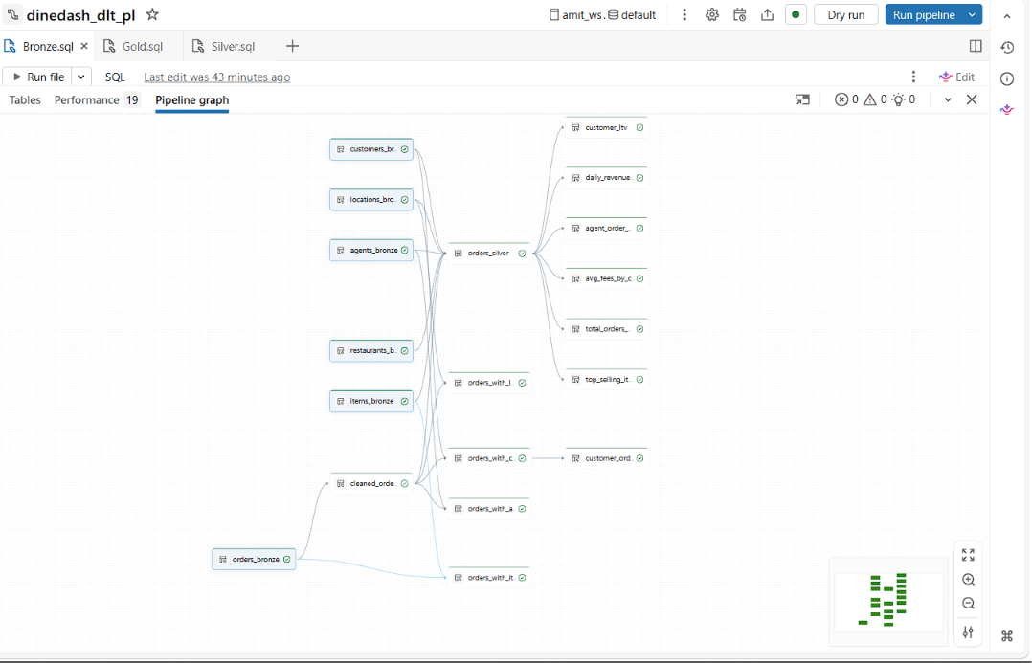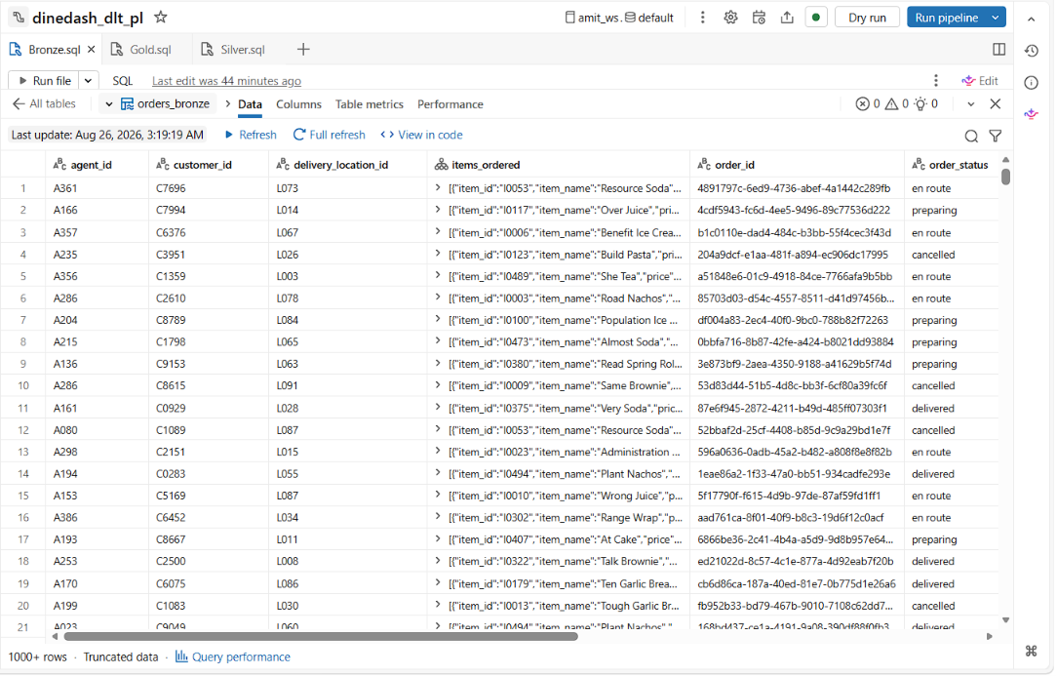

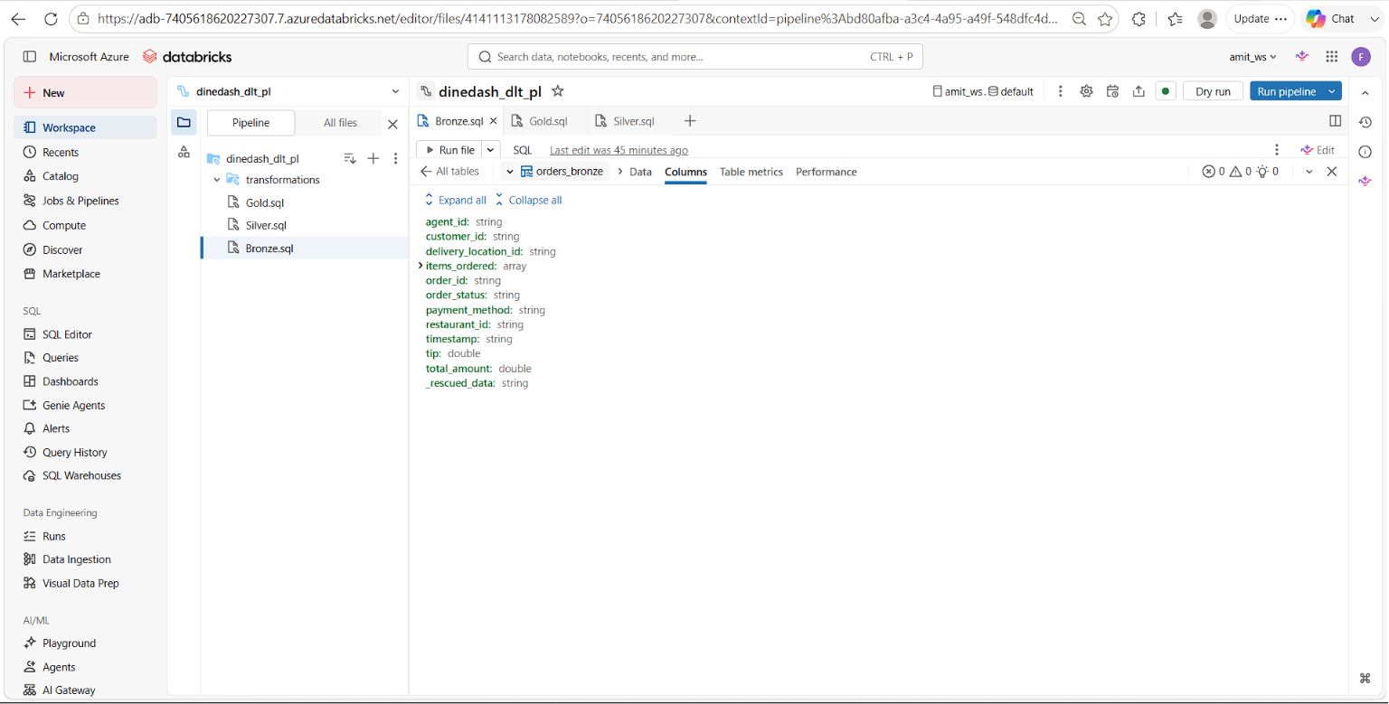

JULY AUGUST DATASET INGESTED:
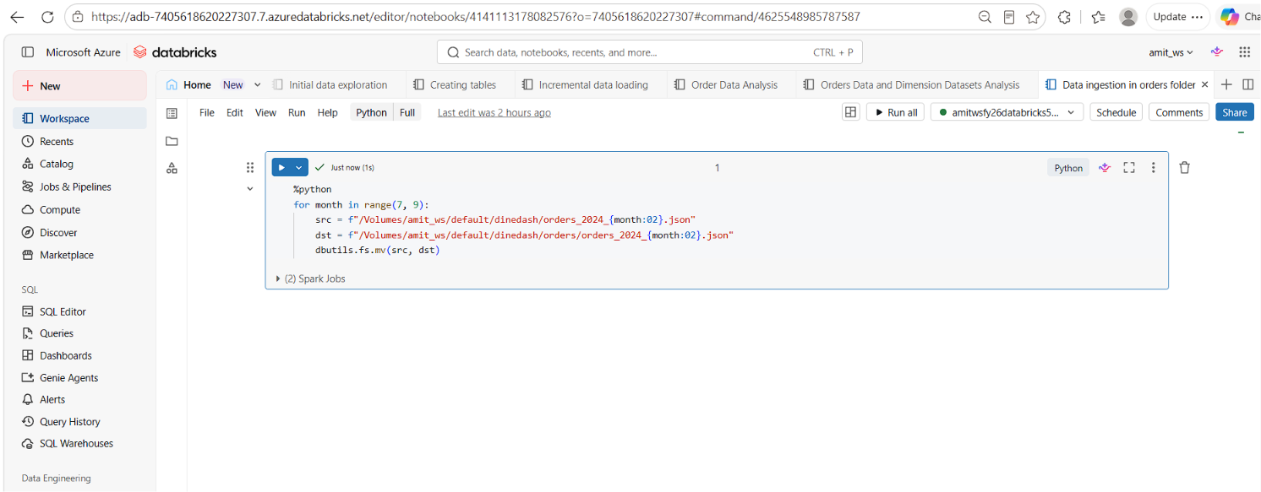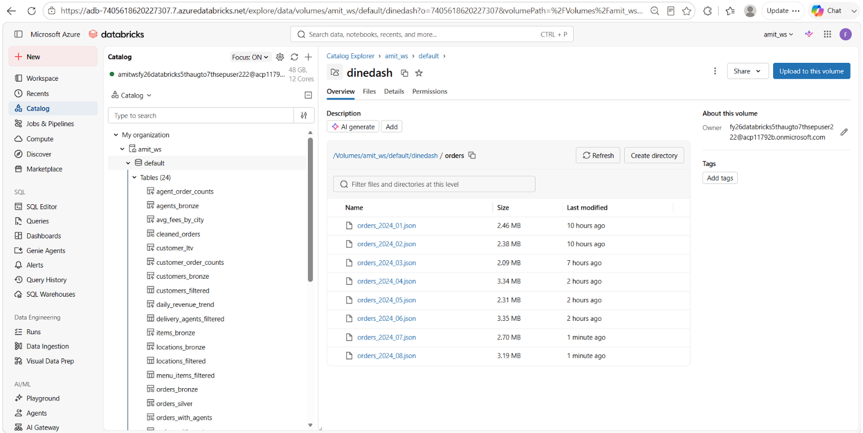
PIPELINE EXECUTION (JANUARY-AUGUST):
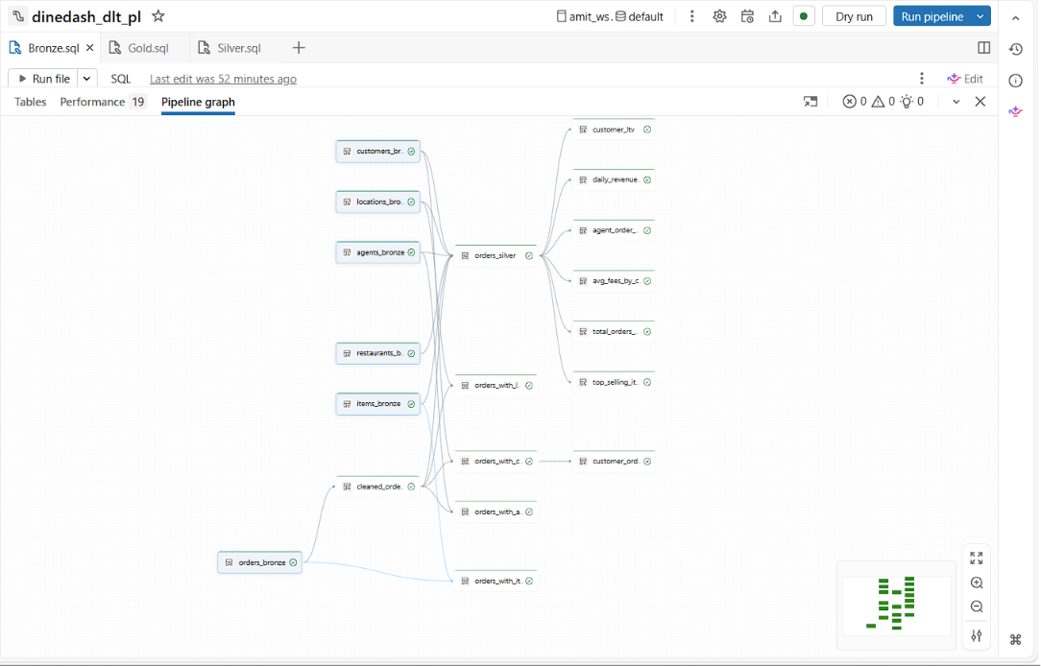

DATA INGESTION INTO ORDERS TABLE (SEPTEMBER, OCTOBER, NOVEMBER, DECEMBER):
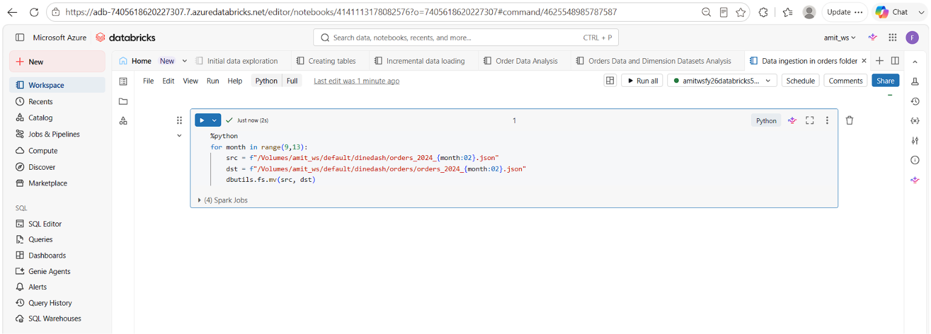

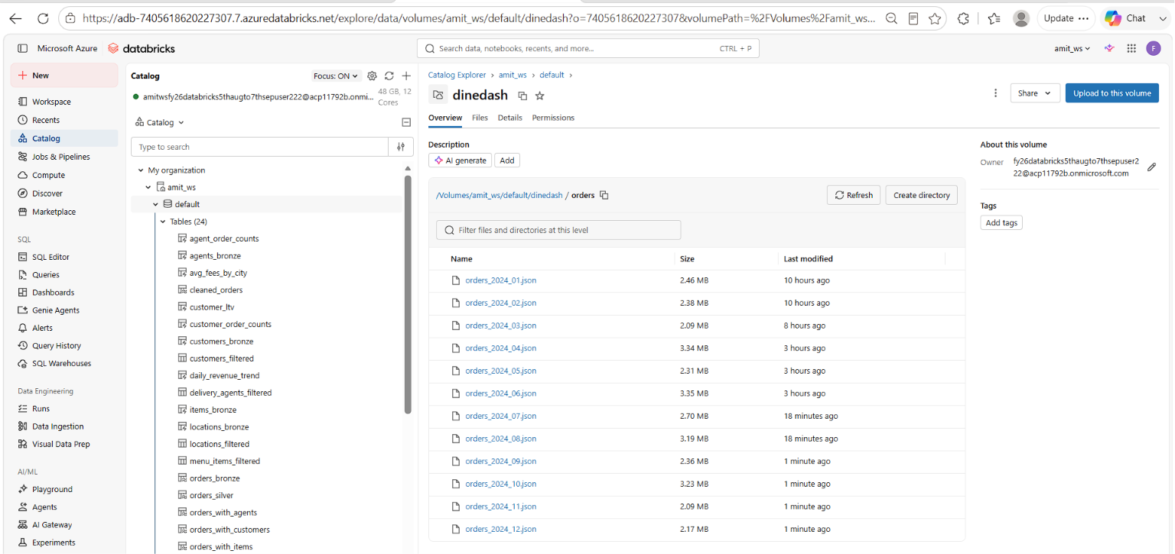

PIPELINE EXECUTION (JANUARY-DECEMBER):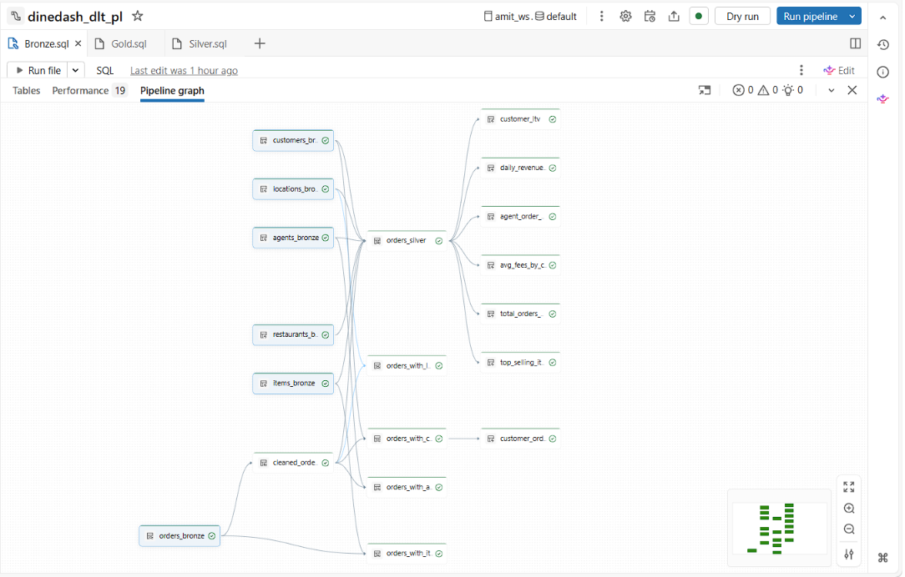 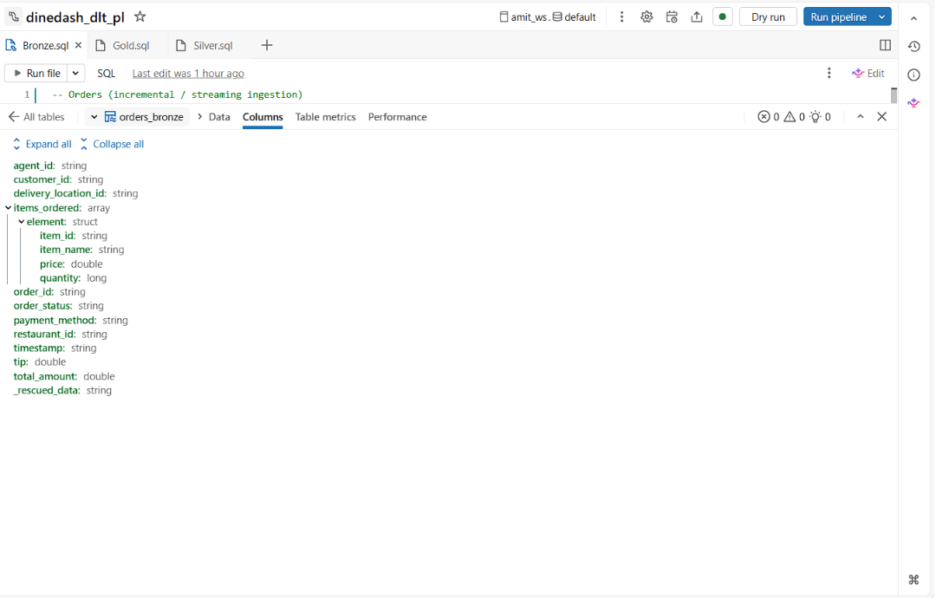 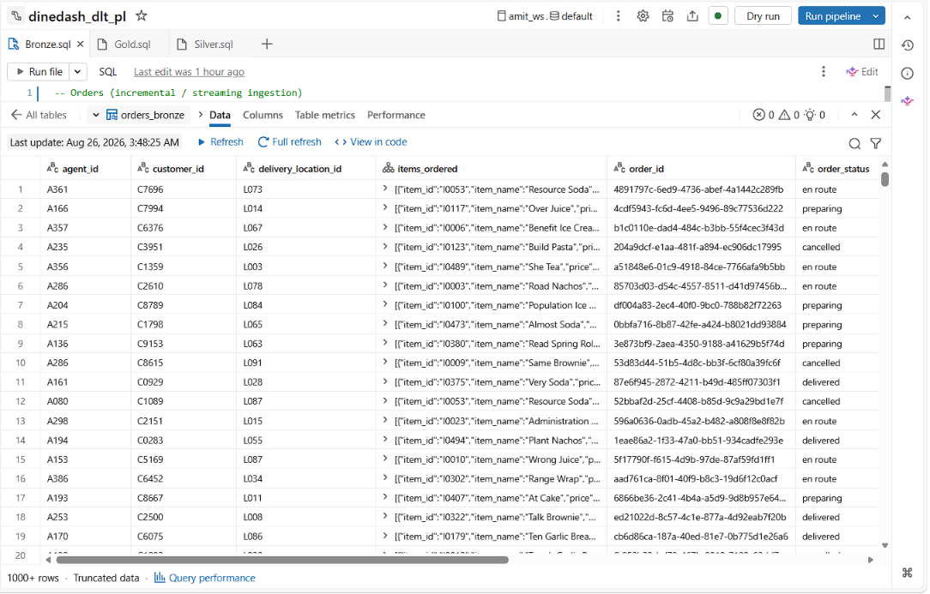 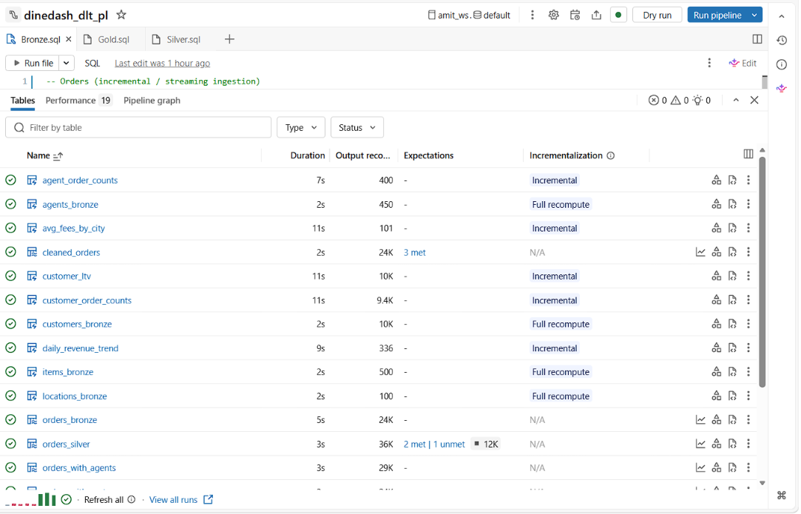

QUERIES(JANUARY-DECEMBER):

Total_orders_per_restaurant:
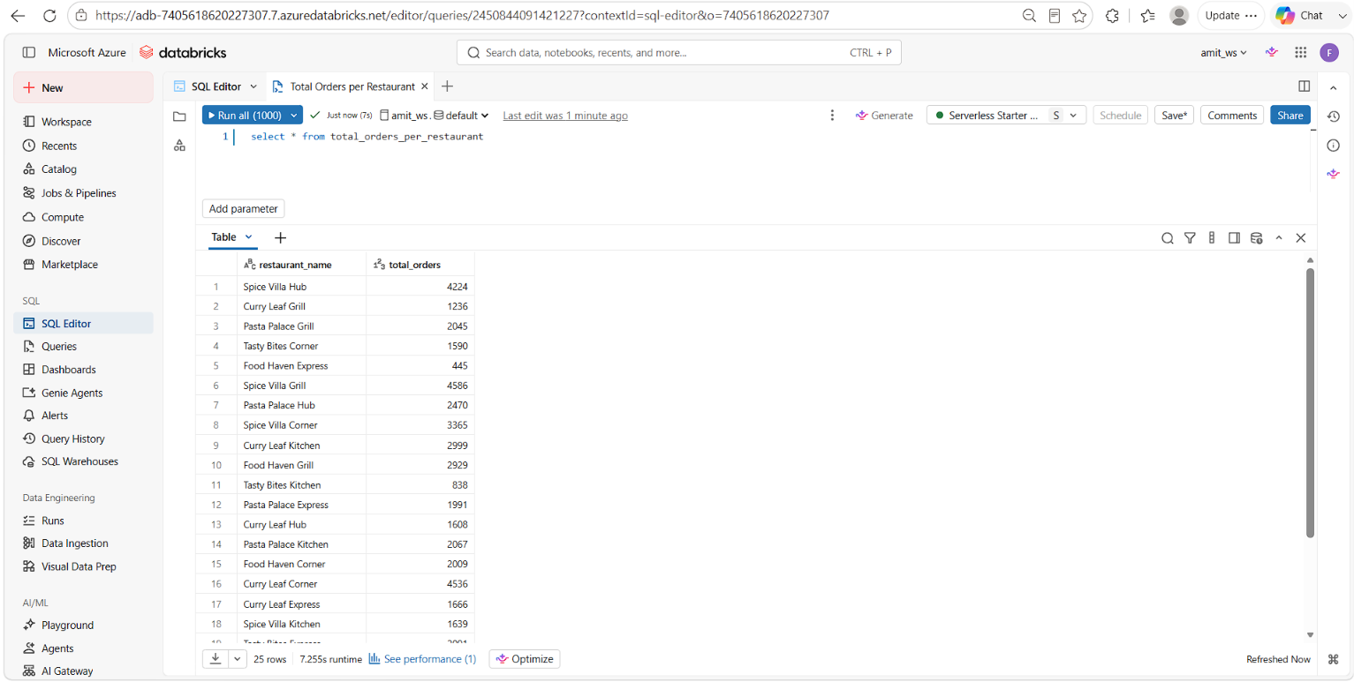
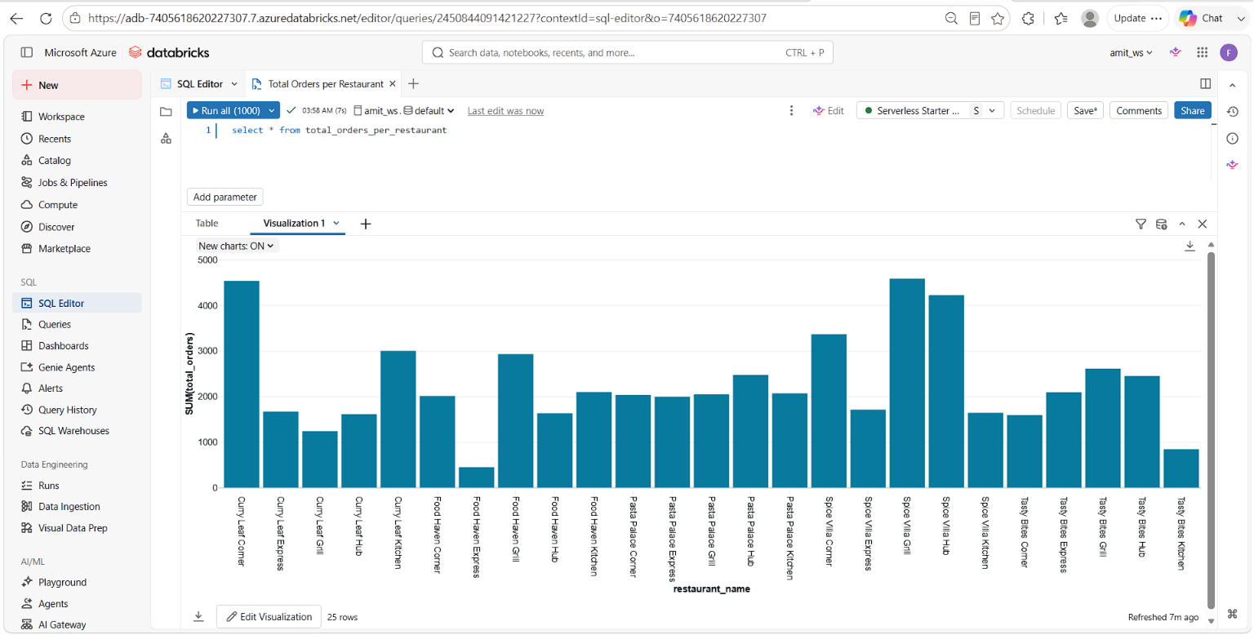

Top selling items:
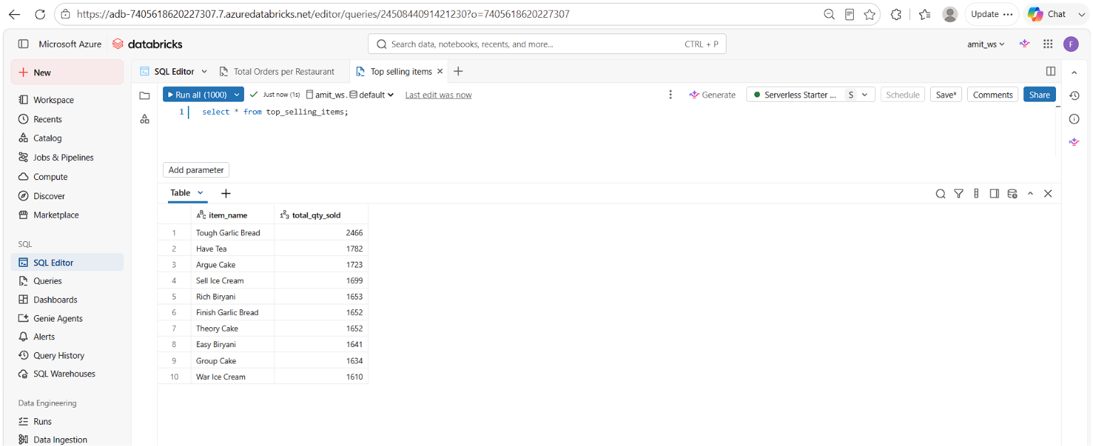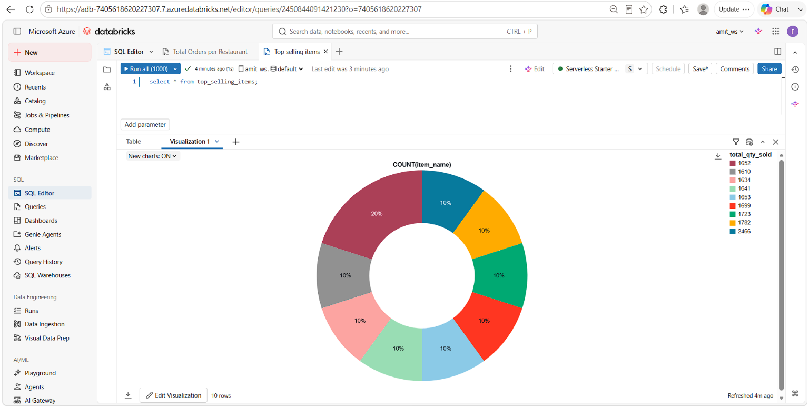

Daily revenue trend:
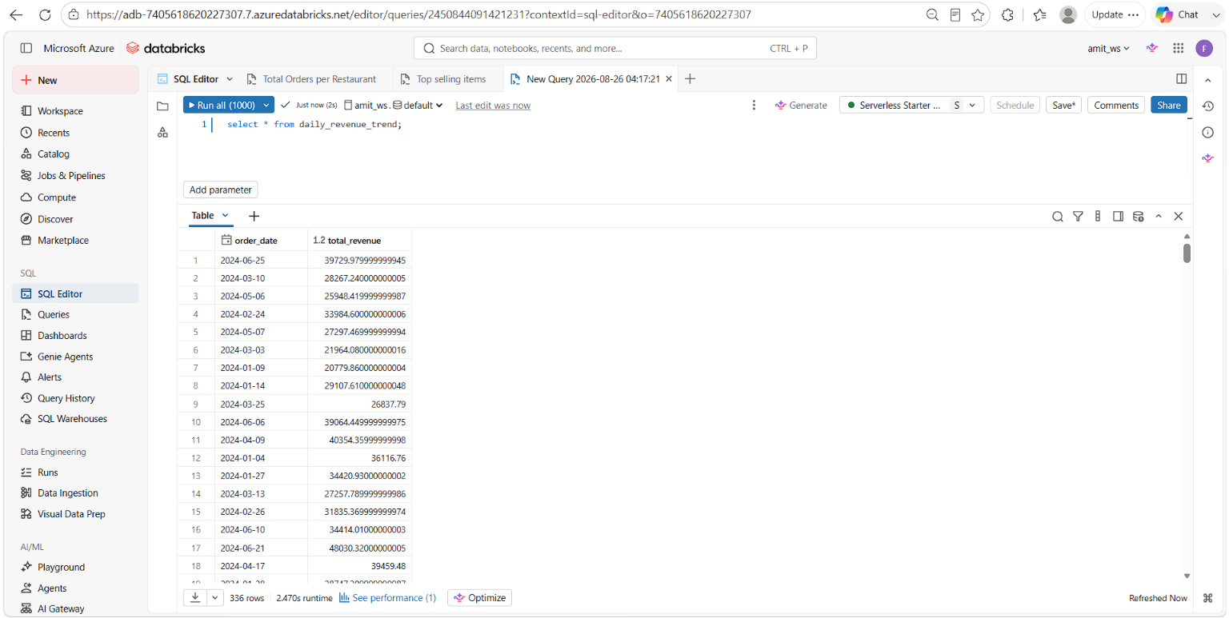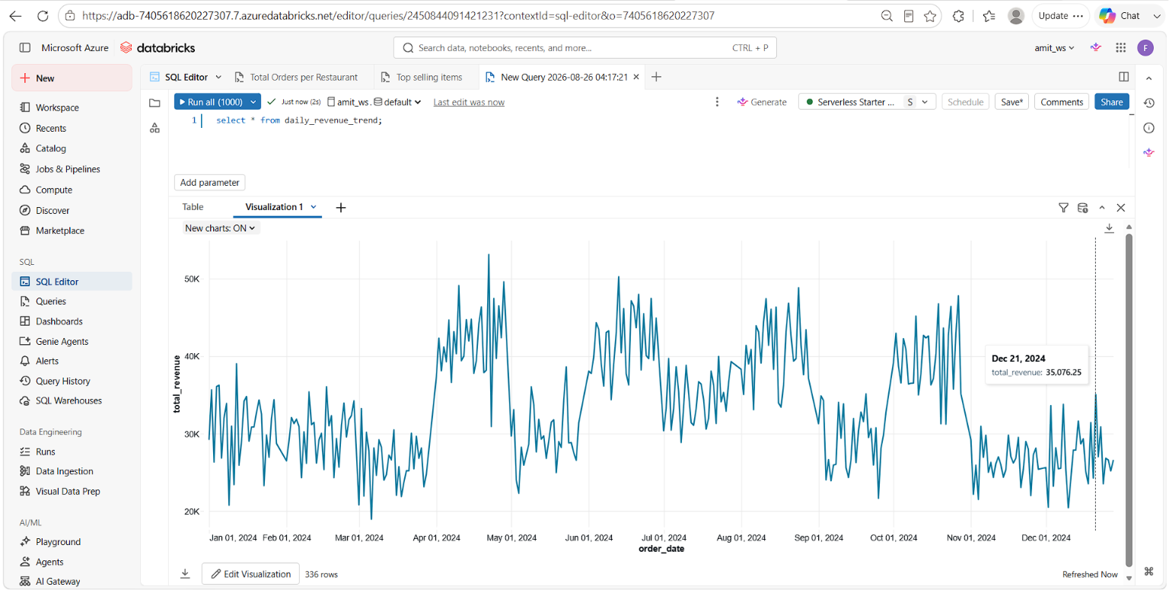

Total Revenue:
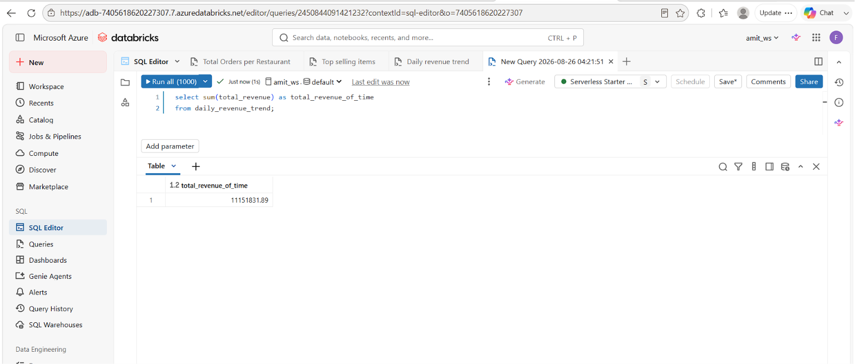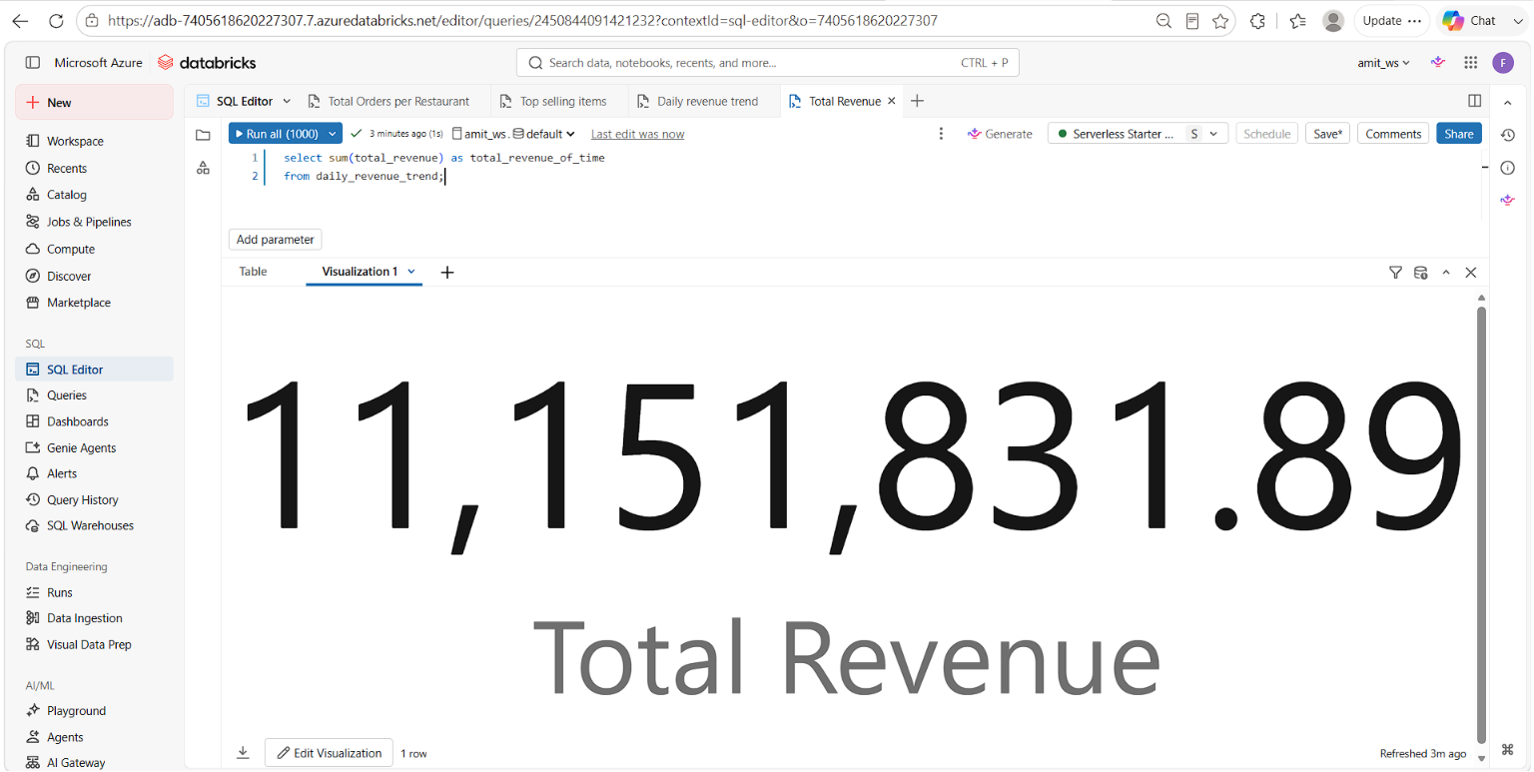

DASHBOARD:
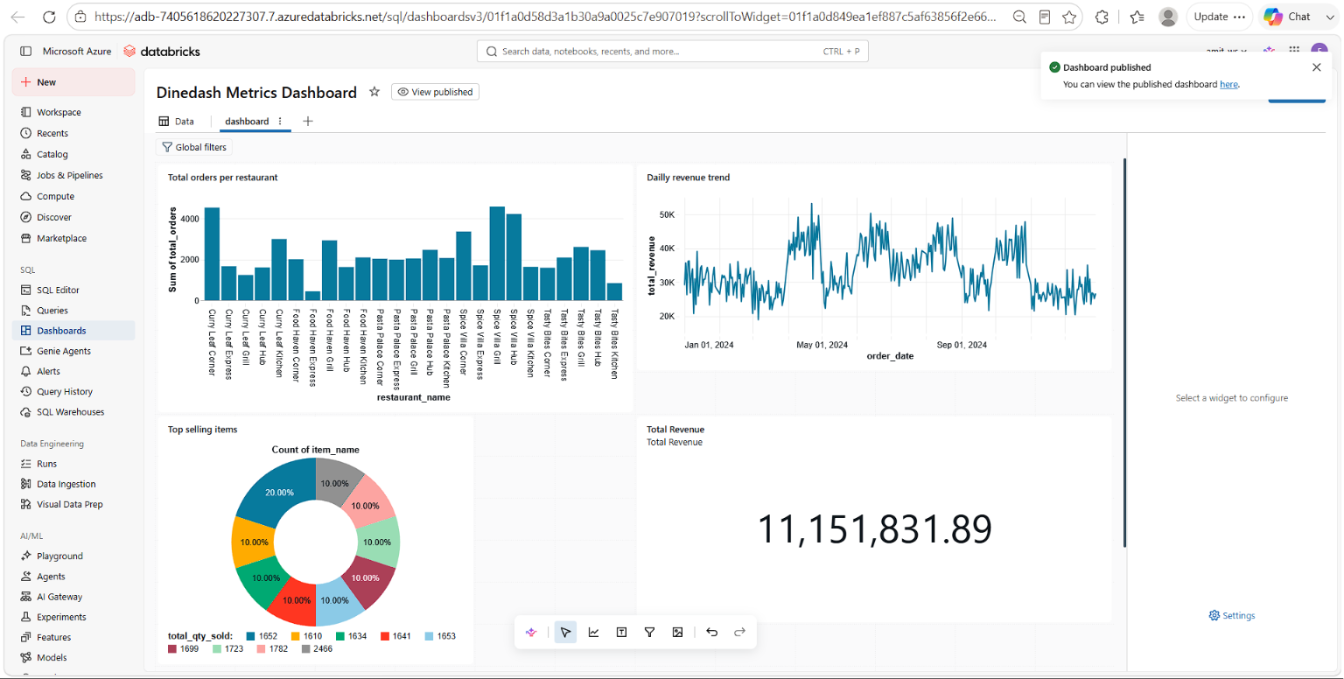
CREATION OF WORKFLOW/JOB:
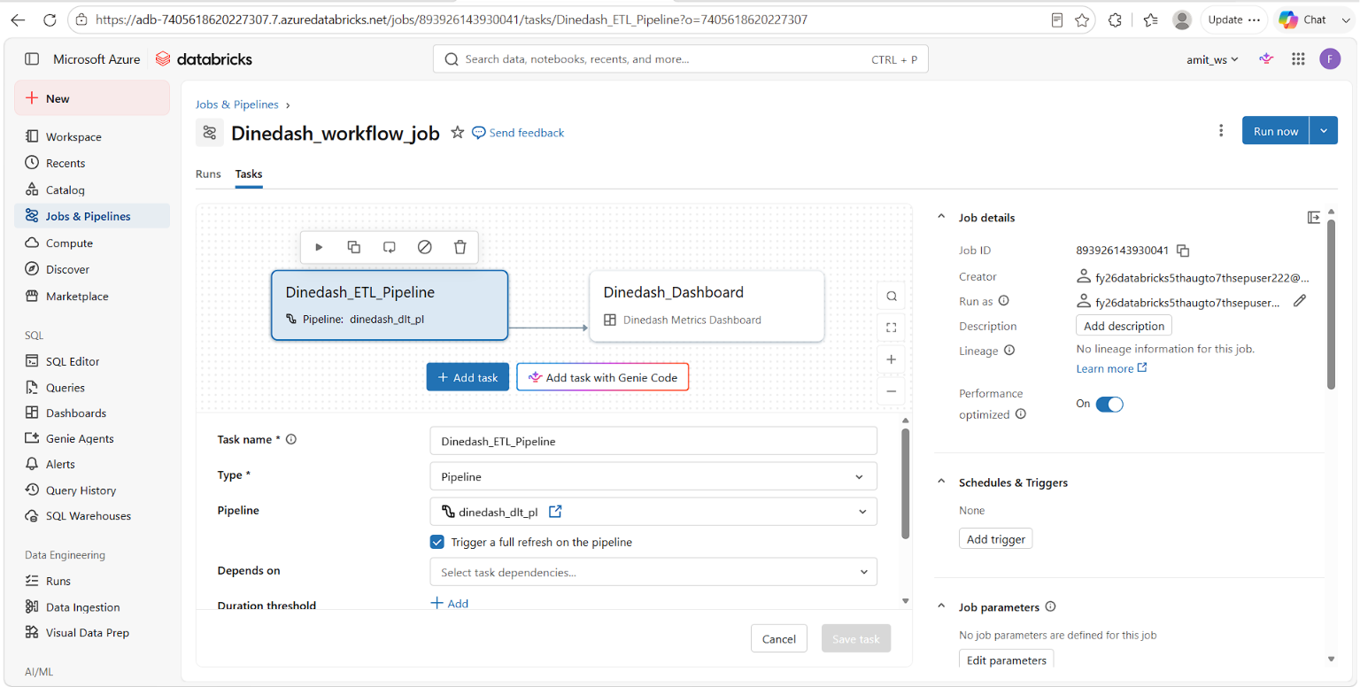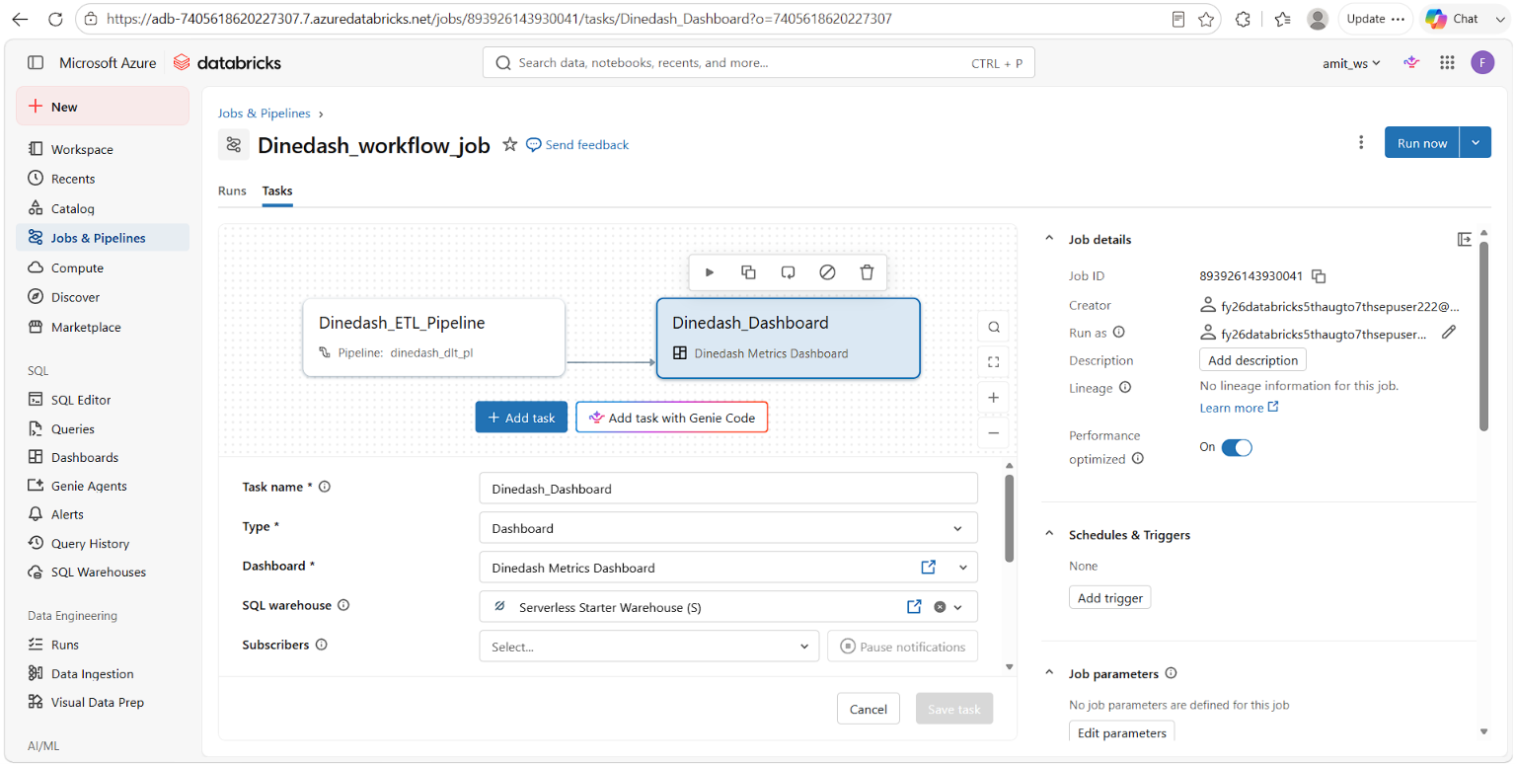

JOB RUN(JANUARY TO DECEMBER):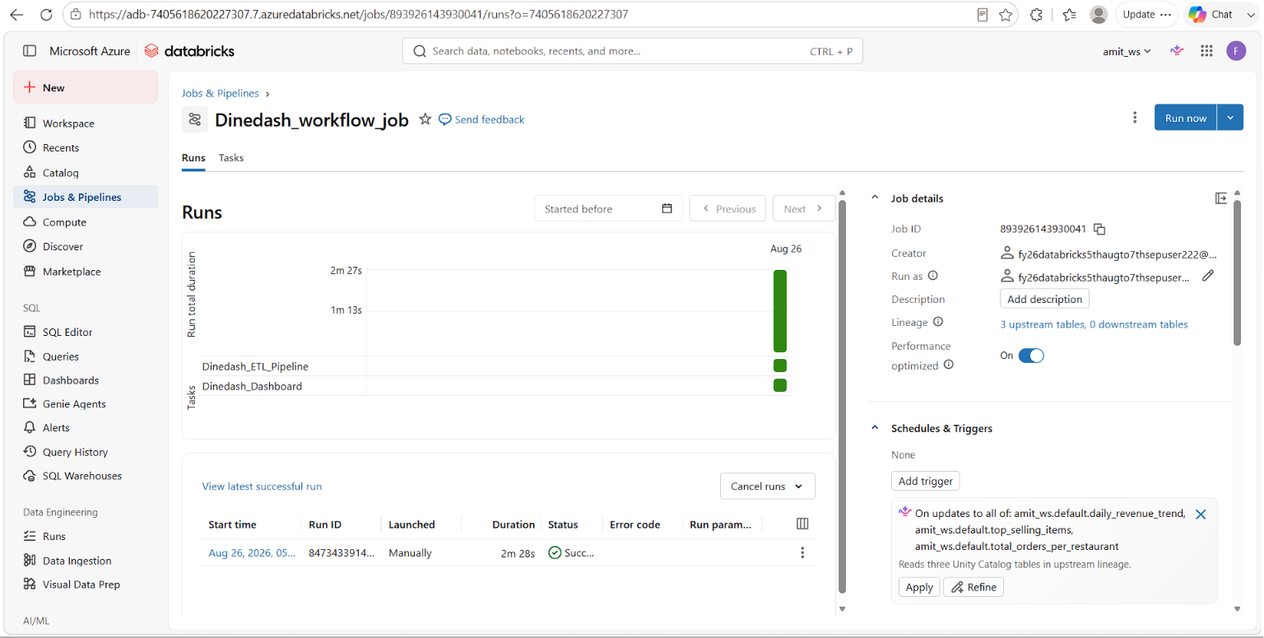
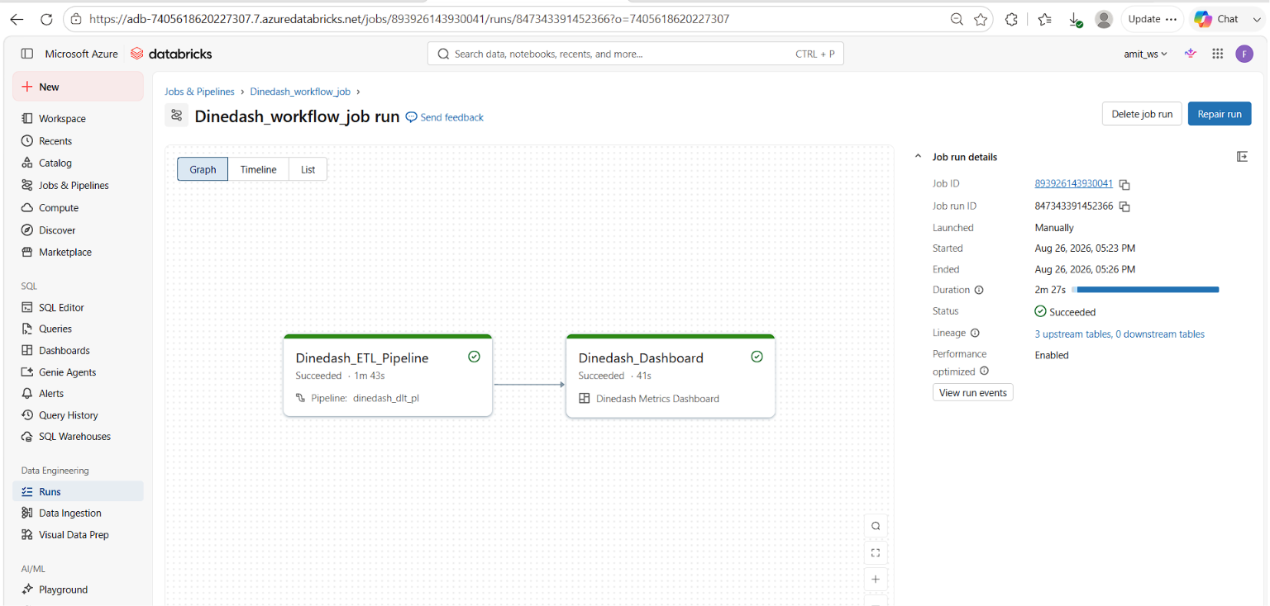
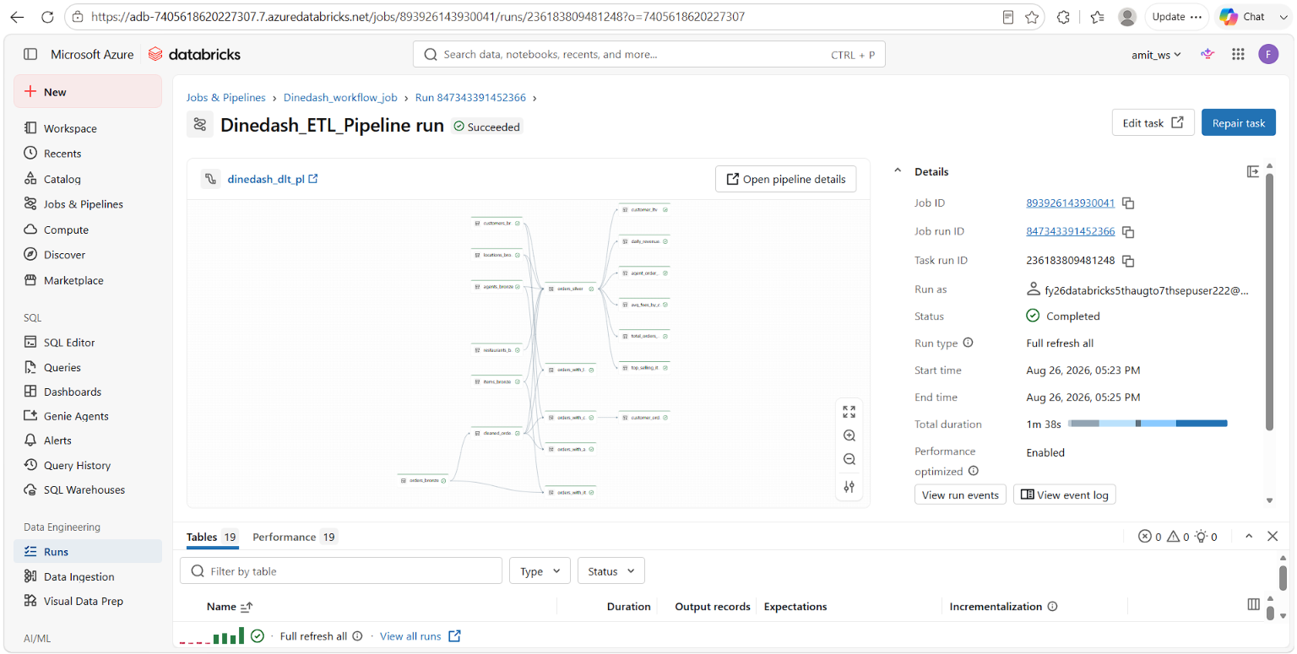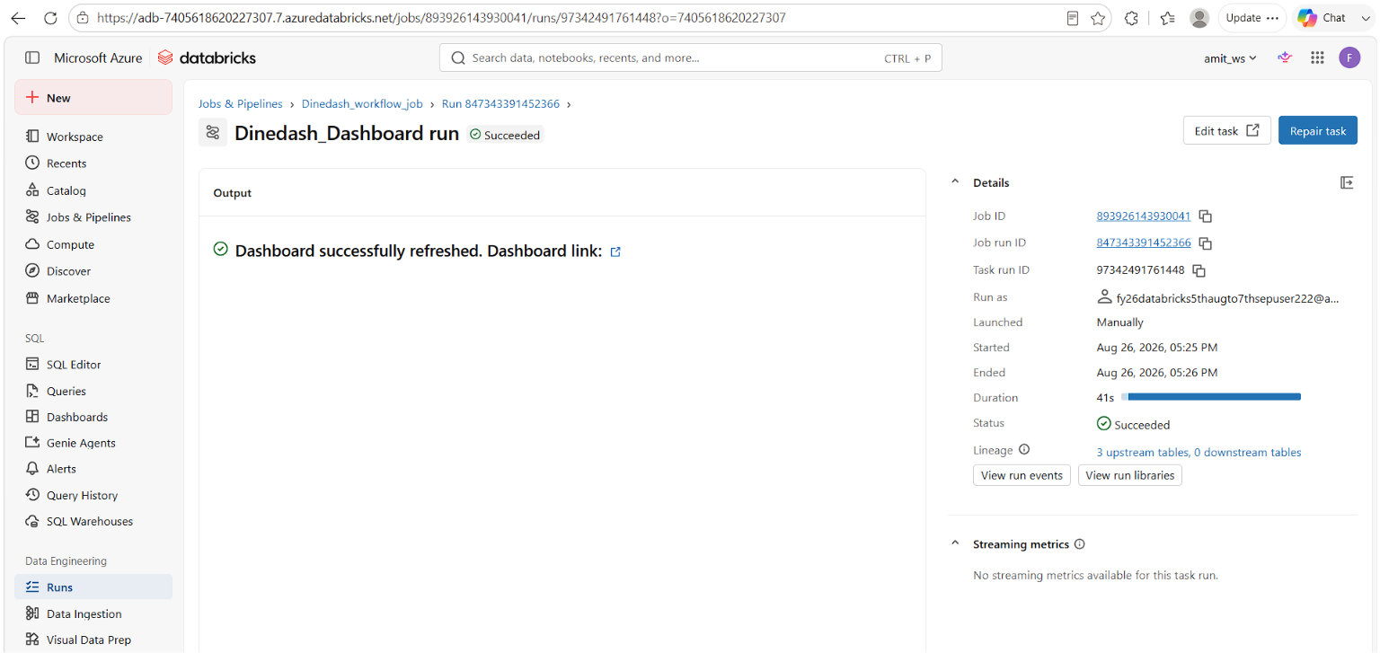

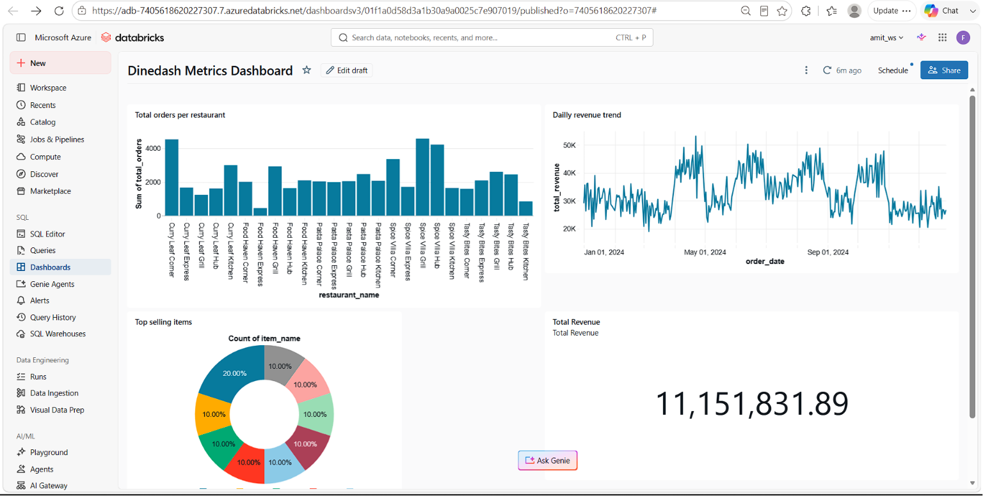
JOB RUN(JANUARY TO AUGUST):